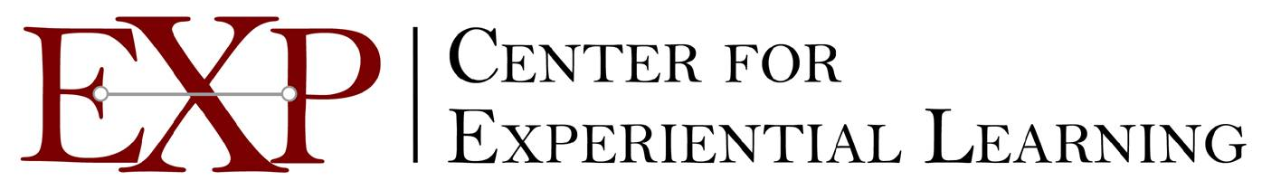

A Unit in the Office of Undergraduate Education at the University of Washington

September 2005

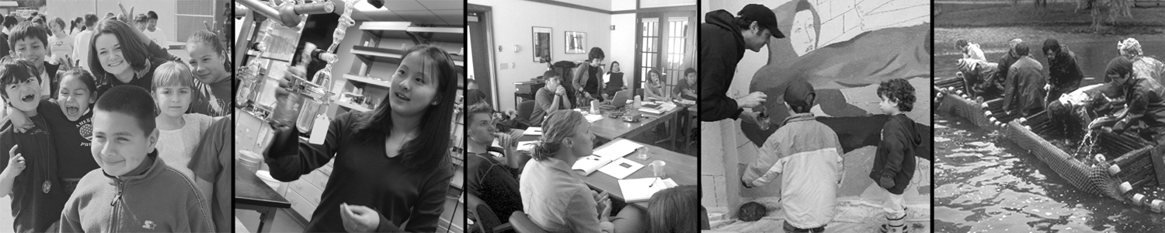

The Center for Experiential Learning (EXP) connects UW undergraduates with opportunities to participate in research with faculty, to engage in community-based learning and leadership, and to compete for local, national, and international scholarships. Center staff also support faculty and departments to integrate service learning and research into their courses and degree programs.

Highlights of 2004-05
EXP was established in 2004 by bringing together six separate units from within OUE: Carlson Leadership and Public Service Center; Jumpstart (with the Office of Minority Affairs); Pipeline Project; Undergraduate Research Program; and the Undergraduate Scholarship Office. The Center also facilitates scholarship selection for the Mary Gates Endowment for Students.

In 2004-05, EXP program accomplishments include the following highlights:

- Invested more than $1.17 million in competitive awards to 325 Mary Gates Scholars engaged in leadership, research and scholarly activities.
- Aided UW nominees toward attainment of Beinecke, Churchill, Gates Cambridge, Goldwater, Merage, Truman, and Udall scholarships and finalist status for the regional Marshall, Mitchell, and Rhodes competitions.
- Placed more than 2,700 undergraduates in the community through service learning, internship, and tutoring positions.
- Expanded the Alternative Spring Break health and literacy projects in rural Washington to include 65 UW students, 9 towns and 833 K-12 students.
- Showcased the research of 524 undergraduates at the Eighth Annual Undergraduate Research Symposium.
- Doubled funding from the Washington Research Foundation for the Research Fellowships for Advanced Undergraduates.
- Received endowed funds to establish the Carlson Internships to foster civic engagement.
- The Fourth Annual Summer Institute in the Arts and Humanities, created by the Undergraduate Research Program, was featured in the Reinvention Center at Stonybrook’s “Spotlight” series, and used as a model for a pilot program at University of South Florida.
- Three of EXP’s program directors were elected to national professional boards in their program areas.

UW annual accountability data show that in academic year 2004-05, 3,977 student-quarters of intensive undergraduate research and 4,241 student-quarters of university-sponsored service were achieved, with many of these student placements facilitated and/or sponsored by EXP programs.

Background on Experiential Learning at the UW
Since the mid-1990’s, undergraduate participation in research and public service, and UW students’ success in garnering prestigious scholarships have grown dramatically. This growth is due to innovations introduced by the EXP programs (Carlson Center, Pipeline, Jumpstart, Undergraduate Research Program, Undergraduate Scholarship Office, and the Mary Gates Endowment for Students), increased student demand, and institutional and national priorities that recognize the importance of the integration of research, service, and learning at the undergraduate level.

In 1995, the UW chose undergraduate participation in research and service as one of its “annual accountability measures” to report to the state legislature. The chart below shows these accountability data, indicating growth in both of these areas (easily surpassing the original goal of doubling initial participation levels within five years.) The activities of EXP programs, collaborations with academic departments and other campus units such as the Office of Minority Affairs, the Office of Research, and the Simpson Center for the Humanities, and mentorship provided for students by community leaders and faculty from all of UW’s departments and colleges contributed to this success. UW resources, private gifts, and grant-funded efforts have been critical to making these opportunities increasingly available to students.

The Undergraduate Scholarship Office disseminates information about scholarship opportunities to the campus at-large and works intensively to support campus applicants for national prestigious scholarships. The chart below indicates a major change in activity since 1999-2000, including a dramatic increase of campus nominees as well as scholarship competitions supported by the office.

Year | National Scholarship Processes Facilitated | Campus Nominees | Finalists | Awardees
1999¹ | 5 | 6 | 6 | 6
2000² | 7 | 16 | 9 | 6
2004³ | 14 | 50 | 26 | 17
- Scholarships include Barry M. Goldwater, Marshall, Rhodes, Harry S. Truman, and the Morris K. Udall Scholarship Programs.
- Scholarships include Beinecke, Barry M. Goldwater, Marshall, George J. Mitchell, Rhodes, Harry S. Truman, and the Morris K. Udall Scholarship Programs.
- Scholarships include Beinecke, Winston Churchill, Jack K Cooke Undergraduate & Graduate Programs, Gates Cambridge, Barry M. Goldwater, Jacob Javits, Marshall, Martin Achievement, Martin Honors, Merage Fellowship for the American Dream, George J Mitchell, Eleanor Davis Pinkham, Rhodes, Harry S. Truman, and the Morris K. Udall Scholarship Programs.

