**HOW TO REGISTER FOR THE DEPARTMENT OF NAVY (DON) COURSE IN CITI**



Navigate your web browser to [www.citiprogram.org](http://www.citiprogram.org) and login. If you have not already registered for an account, [follow these instructions](https://www.washington.edu/research/forms-and-templates/citi-registration-instructions/).

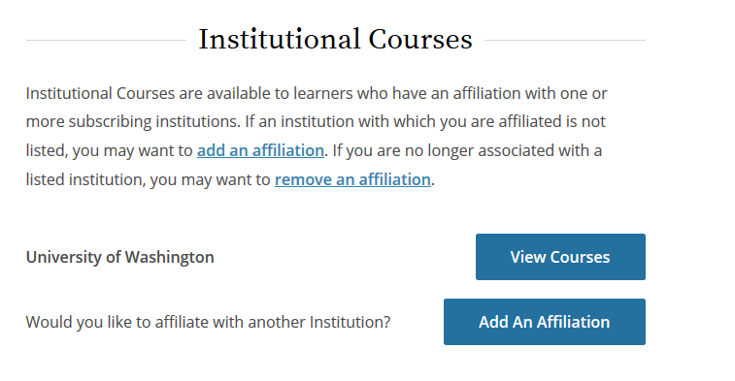

From the Main Menu, select “Add an Affiliation.”

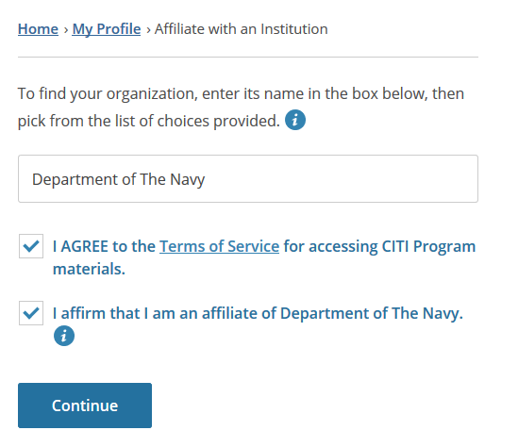

Enter “Department of the Navy” as the organization.

You must agree to the terms of service and affirm your affiliation with Department of the Navy.

Then, click “Continue”.

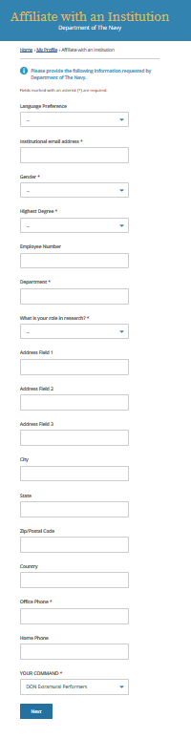

For “YOUR COMMAND”, select “DON Extramural Performers” from the dropdown list.

Then, click “Next”.

Complete the information requested by the Department of the Navy.

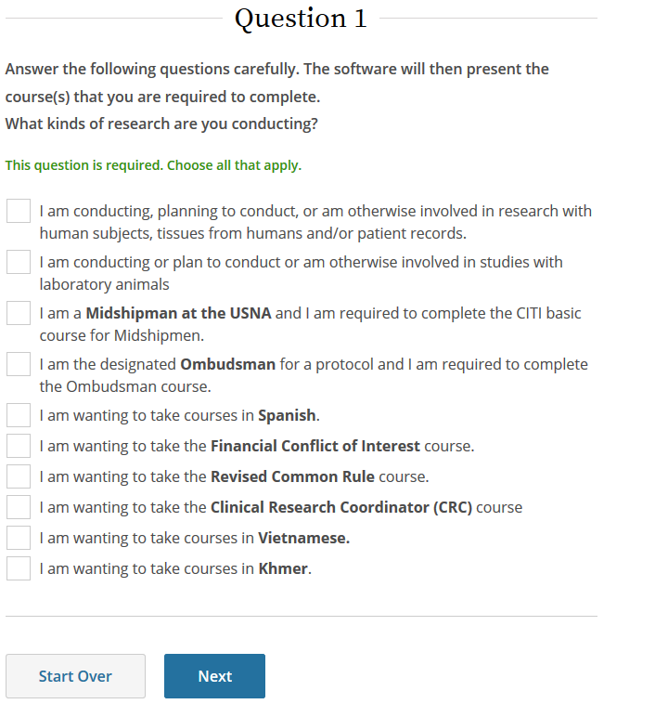

The Department of the Navy instructions and curriculum will now appear.

At the bottom of the page, Select the first box about human subjects research.

Then, click “Next”.

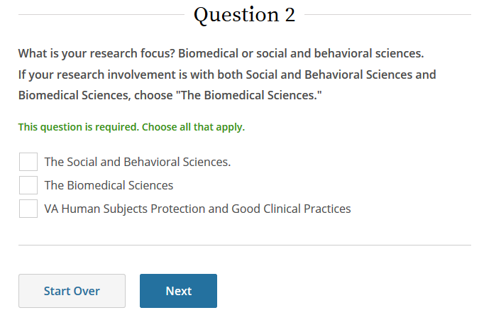

At the bottom of the next page, select your research focus.

Then, click “Next”.

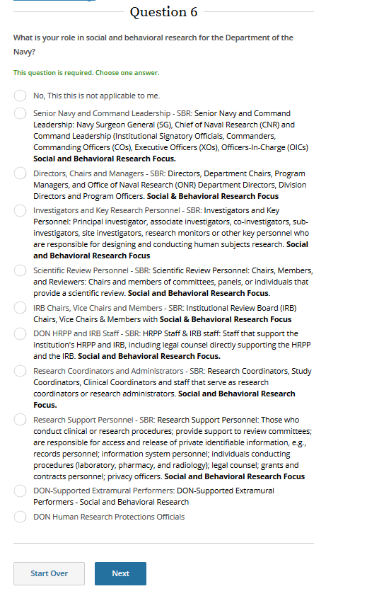

At the bottom of the next page, select “DON-Supported Extramural Performers”.

Then, click “Next”.

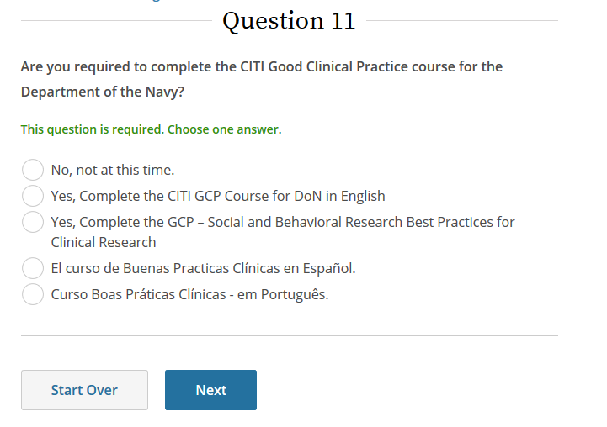

At the bottom of the next page, if the DON supported project you will work on is clinical research, select “Yes”, otherwise, select “No”.

Then, click “Next”.

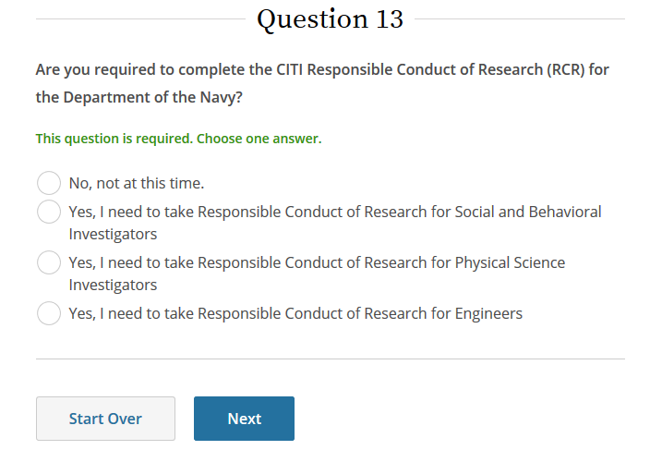

At the bottom of the next page, select “No”.

Then, click “Next”.

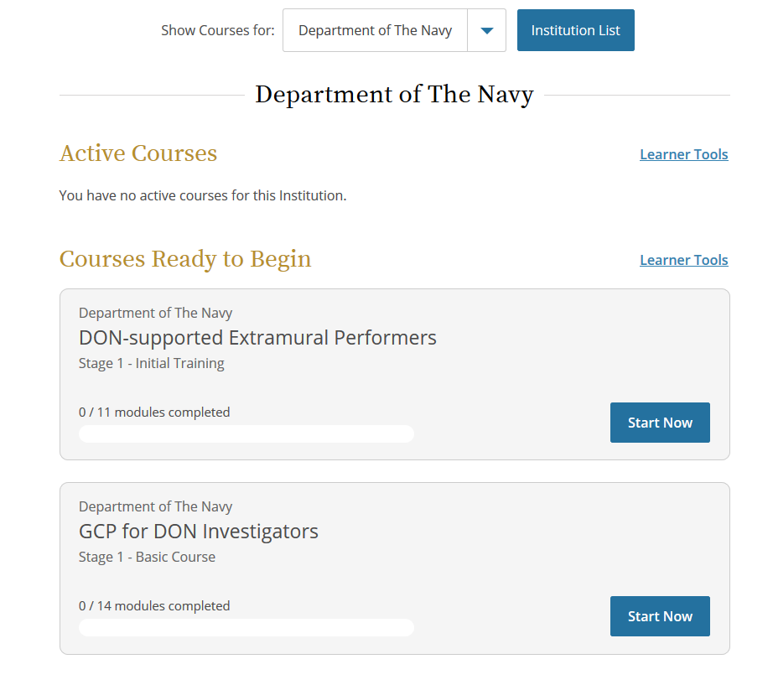

Your active courses for Department of the Navy will now display.

Click “Start Now” to begin the course.

When you have completed the course, save a copy of your completion certificate for your records.