Office of Research Communication Plan
Linda Gamman
Director of Strategic Initiatives and Communication
July 26, 2022

Table of Contents

- Purpose and Goals of the Research Communication Plan ………………………………..……1
- Stakeholders………………………………………………………………………………………………………….1
- Communication Objectives…………………………………….……………………………………………..2
- Roles and Responsibilities of the Director of Communication
and the Communication Team…………………………….……………………….………………………..2
- Research Website…………………………………………………….……………………...…………………...3
- Media Requests……………..………………………………………………………..….…….….………………12
- Guidelines for Urgent and Time-Sensitive Communication………………………..…..…..….12
- UW Administration: Request the President’s or Provost’s Attendance……………………14

Appendix
Urgent Communication Process and Workflow: Internal and External Audiences
Template: High-Impact/Urgent/Time-Sensitive Communication
MyResearch Project Lifecycle Graphic
Office of Research Annual Communication Calendar

university of washington
OFFICE OF RESEARCH

- Purpose and Goals of the Office of Research Communication Plan

“I’d suggest that the greatest overall benefits/outcomes have included improved awareness and understanding, greater access to timely information, and accountability.”
(Anonymous Survey Respondent)

The purpose of creating a communication plan is to improve the quality and effectiveness of communication both internally (the Office of Research) and externally (campus and beyond). The vision of OR is to create an “outstanding climate of support for University of Washington researchers.” Through use of an effective communication plan, we are able to provide relevant, accurate, and consistent information to all of our stakeholders and to improve our ability to be a resource to the University of Washington research community. The communication plan provides a framework to manage and coordinate the wide variety of communication that takes place across the Office of Research, including all information provided on the Research website. The Office of Research communication plan is constructed on the foundation of our mission, values, and guiding principles.

The communication plan will describe:
- To whom our communications will be addressed – our audiences
- What we want to accomplish - our objectives
- Ways in which our objectives can be accomplished - our goals
- How we will accomplish our objectives – people, tools, and timetables

The goals of our communication strategy include:
- Regular and systematic targeted feedback with the goal of continuously develop communication strategies to serve the research community.
- Build strong relationships and improved channels of communication with faculty, staff, partners, and stakeholders.
- Foster transparency and accountability.
- Provide web information that is up-to-date, easy to access, and delivers the information and resources our stakeholders need to do their job.

- Stakeholders

In this plan, we will refer to our stakeholders – either internal stakeholders or external stakeholders. Descriptions for these two audiences are:
Internal stakeholders:
- All Office of Research personnel
External stakeholders:
- UW campus staff and faculty
- MRAM
- Process partners (groups where our processes intersect, e.g. GCA, Financial Management, marketing and communication, other units, etc.)
- Sponsors (NIH, NSF, etc.)
- Peer institutions
- Industry partners
- General public
- State and federal government
III. Communication Objectives

- Encourage and promote open and clear communication within the Office of Research
- Monitor consistent messaging across OR
- Establish processes for feedback
- Establish procedures for continuous process improvement
- Systematic evaluation of the content
- Improve access to key information
- Provide compliance and regulatory resources
- Instill confidence in the level of service and expertise of OR staff
- Raise awareness of the services offered by the Office of Research
- Assist our research community in communicating the benefits of research to the general public, industry partners, and to our state and federal government stakeholders
- Communication regulatory and systems changes, new and/or improved resources, updates to web information, training resources, and research data
- Communicate our reputation

- Roles and Responsibilities of the Director of Communication
and the Communication Team

There are two main communication roles within the Office of Research. These roles work hand-in-hand in implementation of the OR communication strategic plan. Those roles are the Director of Communication and the Communication team.
  - Role and Responsibilities of the Director of Communication
The Director of Communication oversees the implementation of our communication strategic plan that includes announcements and publications (print and web).
- Serves in the role as Business owner of the Research website with the goal of presenting accurate and timely information to our campus partners.
- Develop and oversee communication plans and vet as appropriate with internal or external stakeholders.
- Review selected communication pieces to make sure that stakeholders are aware of upcoming communication plans, ensure the messaging is consistent, and disseminate broadly to internal and external stakeholders as appropriate.
- Ensure consistent messaging across units for all audiences (units, campus, process partners, and researchers) and all mediums:
  - Provide review of communication plans and messaging when appropriate to ExCom, OR Leadership meetings, staff, and/or subject matter experts.
  - Provide review of communication plans and messaging to process partners.
- Lead of the Office of Research Communication Team that consists of unit communication leads and subject matter experts (SMEs) on a research topic area. This group is responsible for review of upcoming communication plans, web updates, development of new resources, and triage of urgent or time-sensitive communication (may include new or updated federal requirements). This group is responsible for developing, communicating, and implementing communication strategies, and review of communication plans, campaigns, and web resources.
- Approve all Marketo roles for OR publications and approve email campaigns.
  - Role and Responsibilities of the OR Communication Team
The roles and responsibilities of the Communication Team include:
- Collaborate and share communication plans.
  - Use approved templates as appropriate.
- Oversight and audit of web content by unit (see Web Governance and Editorial Structure documents posted on the OR Intranet).
- Use of the Marketing brand for all communication including web content.
- Assist with the development and implementation of our communication strategy to establish a system of continuous improvement within the Office of research.
- Preparation of an annual plan for OR communication.
- Populate Outlook Communication Calendar for unit publications and messages.
Some communication team members will serve in one of the Marketo roles, and may have the role of Advanced Marketer (as long as they have completed all required training) so they are able to approve emails for their unit or other OR units as requested.
- Research Website

  - Research Website Goals
The Office of Research website is developed and maintained with four main goals always in view:

Goal #1: Create and sustain an integrated research community hub.
Goal#2: Enhance the research enterprise.
Goal#3: Leverage architecture and design to support user-focused, activity-based, seamless website interaction.
Goal#4: Support a long-term sustainable strategy for maintaining a robust research website.
  - Innovative and Groundbreaking Website Navigation
We accomplish these goals by providing campus with key information: compliance, policies, resources, training, business and system processes, unit information, and contact information. As our mission is to support research administration, we focused our architecture in the language of our research staff and faculty – the research project lifecycle; the depth and breadth of the ways in which we provide information within this construct is truly innovative and groundbreaking!

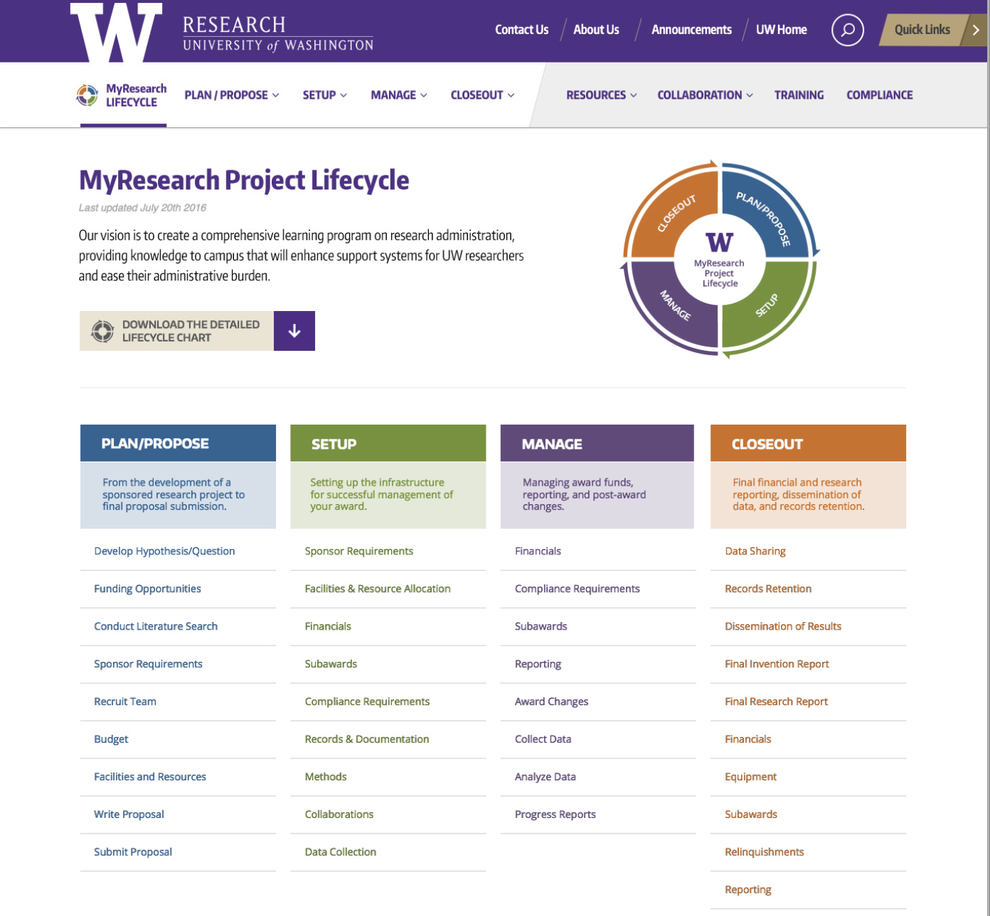
  - Governance Roles and Responsibilities for the Research Website
Multiple groups provide important oversight within the research website:
- Executive Sponsors
- Web Vision Group
- Web Strategy Group
- Web Stakeholders
- Business Owner

- Website Executive Sponsors
  - Mari Ostendorf, Vice Provost for Research and Jim Kresl, Assistant Vice Provost and Director of ORIS, serve as the Executive Sponsors for the Office of Research website. All members of the Web Vision Group and the Web Strategy Group report to our website sponsors regarding implementation of website goals and strategies.
- Web Business Owner
  - The Director of Strategic Initiatives and Communication serves as the Research website business owner and is responsible to all internal and external partners and constituents for oversight and website sustainability.
- Web Vision Group
  - The Web Vision Group is intended to advise and support the development of the OR web presence while aligning with the University of Washington strategic initiatives, reputation and brand. The group is comprised of selected individuals within OR units. The members of the Web Vision Group are Joe Giffels (ORC), Linda Gamman (ORC), Matt Orefice (ORC), Breona Gutschmidt (ORIS).
- Web Strategy Group
  - The Web Strategy Group has membership from all OR units and is responsible for carrying out our overall vision, and creates and maintains accurate content, and will advise on website changes in both architecture and design.
- Web Stakeholders
  - The Stakeholders for the Research Website are our research partners whose content ties to the Research Lifecycle at every level. We will contact them on a regular basis for content review.
  - Website Sustainability and Maintenance: Research Web Site Governance and Editorial Structure
The purpose of the governance and editorial structure is to accomplish our fourth website goal of supporting a long-term sustainable strategy for maintaining a robust research website.

- Objective
  - The objective of the governance structure for the Office of Research website is to facilitate the ongoing development and long-term sustainability of a robust and effective research website while keeping the goal of a task-based structure modeled after the MyResearch Project Lifecycle.
  - Currently, the website comprises numerous pages, groups of which emanate from specific UW administrative offices within OR such as OSP, HSD, or from ORC on behalf of specific initiatives such as Compliance, Limited Submissions, Research Centers and Institutes, the Collaborative for Research Education (CORE), and other content areas. An individual who, to a greater or lesser extent, fulfills editorial responsibility for the page manages the content of every page and page grouping.

- Benefits of a Successful Governance Structure and Editorial Board
A governance structure provides several advantages for the website:
- Creation and maintenance of a website that is well managed, accurate, and effective.
- Promotes formalized results-oriented performance on the part of individuals managing pages.
- Content “owned” by our research campus partners is accurate and up to date. This requires regular interaction with our SMEs and external stakeholders to agree on strategy and to request content review and updates.
- Provides those managing pages with the organizational support to implement page development and maintenance.
- Provides an editorial structure with levels of authority and responsibility that support page quality and consistency.
- Encourages the sharing and adoption of best practices for page development and maintenance and for improving the look and feel of the website.
- Informs budgetary issues required to support the goals of the website.
- Governance Structure Components
The components of the governance structure include:
- Governance Structure Roles and Responsibilities: Website editorial roles and responsibilities, business roles, funding model, and multiple components of site governance. Authors: OR/ORIS.
- Style Guide: Document and guide includes direction on style, language, and branding requirements. Author: OR.
- Service Level Agreement (SLA): Includes system roles, system uptime, links to system description and security documents, support description and work request process, and training. This document is stored in the “Website Governance” section of the WordPress production site. Author: ORIS.
- Design booklet: describes how to input info into system, use layouts, theme and modules, direction on accessibility. This document is stored in the “Website Governance” section of the WordPress production site Author: ORIS.

- Governance/Editorial Roles and Responsibilities
The governance editorial Board is comprised of multiple editorial roles including executive sponsors, content and guest editors, and vision and strategy groups, with input from individuals from other central research administration units, our partner research units, and research administrators and researchers from academic units. Site governance roles are in the table below:
Governance Role | Name(s) | Responsibility
Executive Sponsor | Mari Ostendorf, Jim Kresl | Approves strategic direction and allocation of resources.
Web Vision Group (WVG) | Joe Giffels (ORC), Linda Gamman (ORC), Matt Orefice (ORC), Breona Gutschmidt (ORC) | The WVG serves to represent the vision of the Executive Sponsors including definition of goals, objectives, and metrics. Will have final approval of the website governance structure. The WVG provides updates to the Executive Sponsors as needed.
Website Integrity Specialist | Linda Gamman- Primary (ORC), Web Vision Group (Secondary) | Oversees how content is structured on the site so it is findable for online users and supports business needs, which includes considering navigation and labeling, and how content is connected throughout the site.  - Acts as steward and curator for all web content as well as the website user experience  - Determines where new content (substantial or high impact) will be placed on the site (in many cases will require input from Web Strategy Group)  - Approves all requests from unit content editors for changes to website navigation (requires input from Web Strategy Group)  - Approves webpages new to the sitemap (requires input from Web Strategy Group)  - Understands how information is grouped and related on the site, and evaluates and defines these relationships  - Tracks content inventory and regular site audits  - Ensures site structure supports the site goals and objectives  - Ensures web content from our research partners is incorporated and maintained  - Ensures alliance with UW marketing themes
Website Platform Technology Manager | Breona Gutschmidt, (ORIS) | Provides CMS technical expertise and management to all units:  - Oversight of all technical aspects of the maintenance process and necessary upgrades  - Provides expertise to CMS users and works directly with Web Vision Group and Web Strategy Group on CMS needs and issues  - Oversight of resourcing for ORIS website development requirements sent by Unit Content Editors
Website Content Manager | Linda Gamman (ORC), Matt Orefice - Backup (ORC) | The content manager has primary responsibility for making day-to-day content decisions and ensuring the delivery of our website goals. Role includes the following activities:  - Accepts project content requests from stakeholders or research partners, reviews, and informs partners of decisions about their project content requests (may work with Unit Content Editors to handle request)  - Owns final site content decisions, making sure that site content requests are completed according to website goals and objectives
Website Content Analyst | Multiple (ORIC) | - Maintains content inventory  - Develops site maps  - Produces site analytics and recommendations based on findings  - Creates and maintains Design Booklet for OR WordPress users  - Provides analysis of WordPress development requirements and makes recommendations to Website Content Manager and/or Unit Content Editors (as appropriate)
Web Strategy Group (WSG) | Breona Gutschmidt (ORIS), Carol Rhodes (OSP), Amanda Snyder (OSP), Mara Rivet (OSP), Jason Malone (HSD), Joe Giffels (ORC), Linda Gamman (ORC), Matt Orefice (ORC) | - Approves changes to the content and tier structure in the MyResearch Project Lifecycle  - Approves changes to website structure and site map  - Functions as the review group for web content with multi-page owners (if needed)  - Functions as the decision making group for best practices for website relevance and sustainability
Unit Content Editor | Megan Tedell-Hlady (HSD), Dolly Morse (HSD), Mara Rivet (OSP), Breona Gutschmidt (ORIS), Emily Elliott (ORIS), Laurie Stephan (CORE/ORC), Matt Orefice (ORC), Linda Gamman (ORC) | Provides and publishes content on webpages in WordPress, which they own, making sure the content is reviewed and routed for approval if necessary. Includes the following:  - Manages the content creation and publishing process from beginning to end, including creating and enforcing content guidelines  - Reviews content from web user perspective, and identifies correct placement for content on site (if necessary)  - Reviews and approves content submitted by partner content providers and/or subject matter experts (SMEs) and publishes content in WordPress for those pages editors own, or routes to the webpage owner to publish  - Creates content using appropriate webpage template and content style using the OR Style Guide (includes images which are considered content)  - Reviews owned web content , ensuring correctness and appropriate formatting for the web, including correct links  - Reviews content for voice, tone, consistency with other materials, and grammar according to OR Style Guide  - Reviews current site unit content for needed changes as part of the maintenance process  - Publishes content in WordPress  - Reviews and forwards recommendations for changes to navigation to Website Content Manager  - Sends request for technical assistance or production support to web1q
Content SMEs and Content Reviewer | Melissa Petersen (FCOI and OW),  Karen Luetjen (RRF/Bridge),  Karen Luetjen, (Limited Submissions)  Laurie Stephan (CORE, Training Grant)  Kim Blakemore (Required Training, ESCRO)  Jeff Babauta (Matching Funds, Financial/Data) | - Writes, approves and reviews content in area of expertise  - Forwards content edits to Website Content Manager or Backup to publish web content in WordPress  - SMEs that are Assistant Content WordPress Editors update and publish content as required
Assistant Content WordPress Editor | Vacant | - Updates and publishes content in WordPress as required/requested  - Provide WordPress technical assistance (non-development technical solutions) to units
Guest Content Provider | Research partners: GCA, MAA, Libraries, OAW, ITHS, SOM, EH&S | Content provided by our research partners is welcome and will be sought out.  - Content provided by our research partners to research@uw will be forwarded to Website Content Manager for review, approval, and for publication in WordPress (unless content is owned by another unit and then the Unit Content Editor will publish in WordPress)  - Unit Content Editor who receives content from partners will review, route for approval if necessary, and publish in WordPress.
Communication Team | Linda Gamman - team facilitator (ORC), Matt Orefice (ORC), Breona Gutschmidt (ORIS), Emily Elliot (ORIS), Megan Tedell-Hlady (HSD), Dolly Morse (HSD), Mara Rivet (OSP), Laurie Stephan (ORC/CORE) | - Provides content for Research home page carousel (content, timing, and approvals)  - Discusses upcoming web communication plans  - Discusses announcements that require a broad delivery plan

- Editorial Policy Changes
Editors will be informed of all policy changes and provided with an updated version of this document.

- Long-term strategy for sustainability: Annual Website Audit
The Office of Research Unit Content Editors will conduct an annual website audit and review of all Office of Research webpages. This fulfills our goal for the website to be sustainable and relevant.
  - Timeline: We will conduct our web audit from May to August annually.
  - Process - Page Owner responsibility to include:
    - Review spreadsheet received from ORIS to note all the pages for which you are as Owner.
    - Review of all webpage pages based on these instructions:
      - Check all page links (internal and external).
      - Verify all content from our research stakeholders and make sure the links work. Work with your stakeholders to update inaccurate content.
      - Conduct a high-level content review to make sure all content is relevant, aligns to the research lifecycle (activity-based), serves the research website goals in some respect, and is up-to-date. If the page is co-owned, please check with the other page owner when making deletions.
      - When reviewing content, cross check other topic owners on multiple page topics and see if some consolidation needs to occur.
      - Review all module content for relevancy and usefulness. You may decide to add or delete module items. If the page is co-owned, please check with the other page owner when making deletions.
      - Check all contact pages for your unit. Make sure you have updated titles as appropriate and removed staff who are no longer working in OR. Please update and repost your org chart if there are any changes.
      - Check page accessibility, including headings, structure and image alt text. Please refer to the OR Design Booklet for additional instructions.
      - Review the media library and our archive pages, and remove old outdated files to keep the library up to date, add Alt text when missing (see Design Booklet).

VI. Media Requests

The process for Phone Inquiries from Media is as follows:
- Send media inquiries to the Director of Communication who will submit the request for review and acknowledgement by the Vice Provost for Research and the Sr. Associate Vice Provost for Research Administration and Integrity. They should be informed of all media requests immediately, as well as the Associate Vice Provosts and other unit directors as appropriate. After review, The Director of Communication will send the media request to the Director for Media Relations/University Spokesperson. We may send talking points (if appropriate) when forwarding the request. Directors may send directly to the Vice Provost for Research and the Associate Vice Provost for Research Administration and Integrity copying the Director of Communication.
- Depending on the request, we may need to notify the appropriate Associate Dean(s) for Research.
- For directors: If you are requested to make a statement to the press (and it is approved by the Vice Provost for Research), your comments should be brief (less is more).
- We are a public institution so requests for data/information will be complied (except personnel information, corrective actions, and other protected material like compliance issues). Do not give more than asked and do not provide anything immediately until checking with your director supervisor who may discuss the request with the Vice Provost for Research and/or the Director of Communication.

VII. Guidelines for Urgent and Time-Sensitive Communication

This section describes guidelines for the process for handling urgent, high-impact, and/or time-sensitive communication. We will use the term “Urgent” for this document. The purpose of this document is to ensure that urgent communications are identified, communicated, and escalated in a timely manner to the parties responsible for the coordination of communication efforts. Our goal is to provide timely, consistent, and comprehensive information to campus.

Definition of Urgent Communication
An urgent communication requires a response and/or action beyond the standard unit communication processes or protocols. Urgent communication has high impact, and/or is urgent, and/or time sensitive. It may require coordination across units, with campus, or external groups. When reviewing a communication piece to see if it fits the criteria of “urgent,” it is important to consider all variables or criteria, stakeholders who may be affected, deadlines, and impact on either the Office of Research or the UW. The template for “Urgent Communication” is useful as a guide to capture all required information (see Appendix).

Assumptions
- All unit directors and communication team members receive this document.
- This process is as a guideline for most likely communication scenarios.
- This document is reviewed on an annual basis and updated as necessary.
- This document is stored on the OR intranet.
- Updates are made to all stored copies of the document.

Roles and Responsibilities

The Director of Communication is responsible for coordinating urgent communications across units or campus. Responsibilities may include:

- Intake and review of urgent communication template.
- Alert communication team and/or directors as appropriate.
- Identify the appropriate medium(s).
- Coordinate of communication piece across units and/or upper administration if necessary.
- Route copies of communication piece(s) as necessary.
- Communicate resolution to communication team and/or directors as appropriate.
- Schedule and facilitate post-mortem meeting.

The Unit Communication Lead is responsible for coordination of urgent communication within their unit. Responsibilities may include:
- Follow the communication process and protocols of their unit
- Review of urgent communication, following the guidelines of the “Urgent Communication” template.
- Alert communication manager.
- Identify the appropriate medium.
  - For Urgent or critical MRAM messaging, the sender may choose to send via the MRAM list, or Marketo. For Marketo publications, note that the OSP Communication Liaison keeps the MRAM list updated monthly. If the sender chooses to send out to the MRAM list via email but does not have authority to send out messages to the MRAM list, they can be forwarded to the ORC or OSP Communication liaison to send on their behalf.
- Coordinate of communication within their unit, directors, or campus.
- Route copies of communication piece(s) as necessary.
- Communicate resolution to communication team and/or directors as appropriate.

Communication Process and Work Flow
The process and workflow chart in the Appendix of this plan illustrate the activities and responsibilities of the communication team in ensuring that urgent communication pieces are resolved in the most effective and efficient manner.

Template for High-Impact/Urgent/Time Sensitive Communication
The template for urgent communication is included in this Appendix. The Director of Communication, the Communication Unit Focal, or our directors may choose to use this tool to gather information on incoming requests for urgent/time-sensitive or high-impact communication. This is a tool for gathering information for the development of a specific communication plan. Please handle all approvals for messaging appropriately

VIII. UW Administration: Request the President’s or Provost’s Attendance

The Office of the President and the Office of the Provost have released new guidance for requesting the attendance of the President or the Provost with the goal of making this process easier, and to make all events with the President or Provost a success!

- You will use one form to invite the President and/or Provost to your campus event. If you are inviting one or both to your event, you only need to fill out the form once. You need to complete this form, for all requests large or small. Do not contact either the President or Provost directly to request their attendance.

- A dedicated staff member in the Office of the President will centrally manage this process. Rachel Northquist will be the central point of contact for all PARF-related events and will work closely with administrative staffs in the President and Provost’s office to guide event approval, calendaring, briefings/prep, and speaking points associated with each event.

- The form should take no longer than 5-10 minutes to complete. Ms. Northquist will gather any detailed talking points and other event-specific information only AFTER the event is approved and added to the calendar.

- Deadlines for briefing information and talking points will be coordinated by Rachel and appropriate staff (e.g. President’s writer) on an event-specific basis. Since the size, scope and complexity of events varies widely, we will work with each office to determine what is needed to make your event as successful as possible.

- While decisions on President and Provost attendance at your event may take some time, we commit to being in contact with your event contact within three working days.

- Sooner is better! The more lead-time we have on an event, the higher likelihood of attendance and success. Please get your requests in as soon as possible – even if event dates and times are TBD.

APPENDIX
- Urgent Communication Process and Workflow: Internal and External Audiences
- Template: High-Impact/Urgent/Time-Sensitive Communication
- MyResearch Project Lifecycle Graphic
- OR Communication Calendar 2018-2019

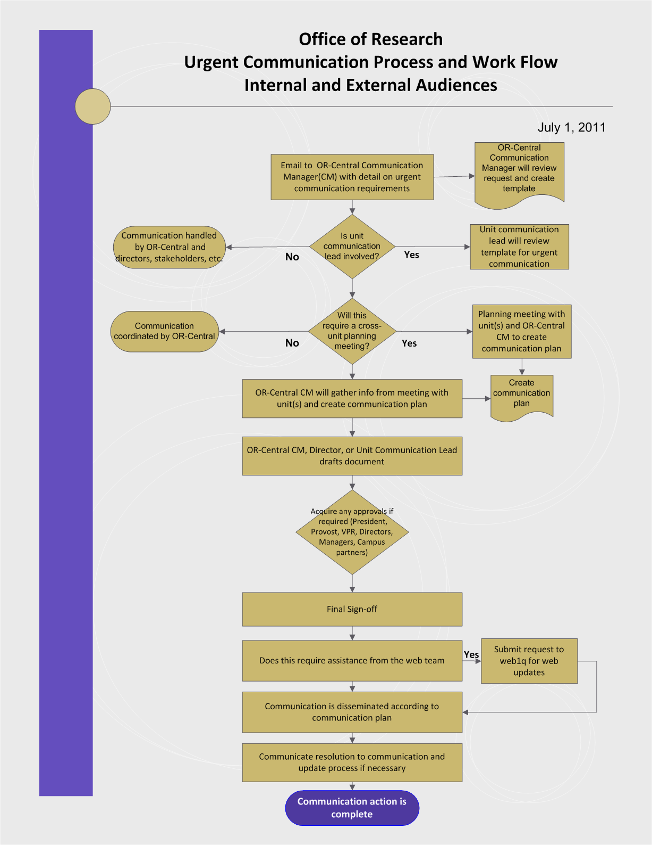
Template
High-Impact/Urgent/Time Sensitive Communication Date Received: _________

Version 3/22/11
Description of communication:

Key internal contacts:

Statement of benefits/risks/impact (if applicable):
For campus:

For OR:

For your unit:

Target date(s) and timelines

Audience/addressee list

CC list
Describe impact and who/which groups are impacted
Medium (s) | Email  Web  Meeting  Other(s): ___________________________
Level of sign-off/approval process | President  Provost  Vice Provost for Research  Director  Supervisor/manager  Other: _______________
Plan for debrief or follow-up (if applicable)
Follow-up for communication team (if applicable)
MyResearch Project Lifecycle

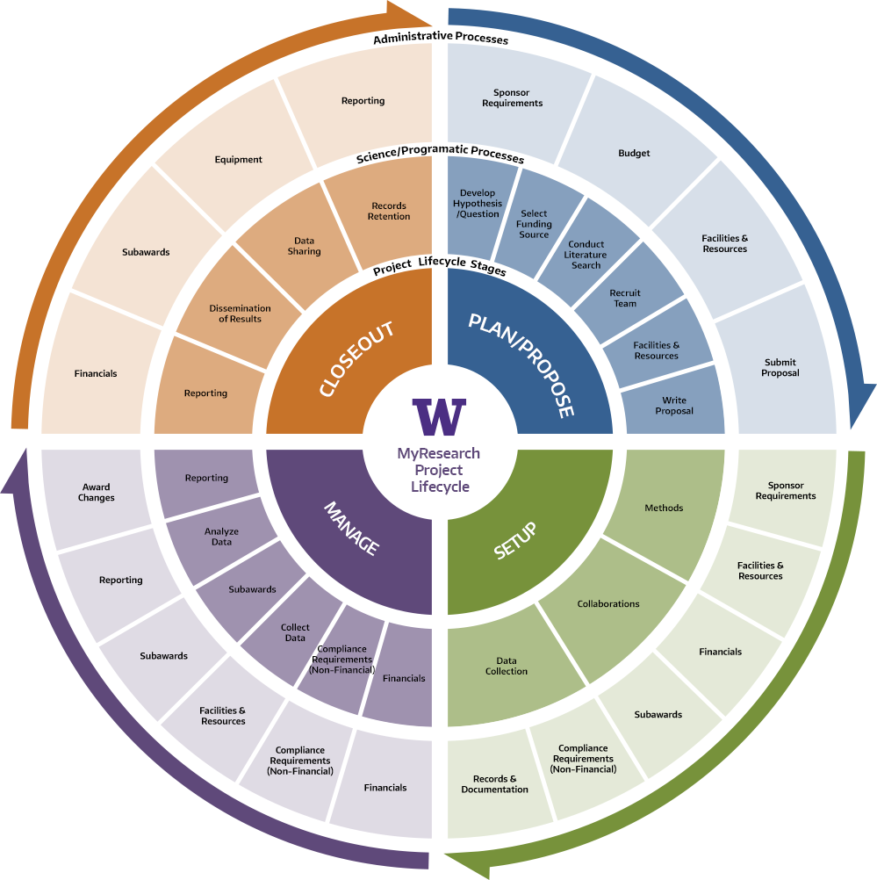
We will associate tools, training and compliance topics to the research project lifecycle stages.

Deadline | Date (general) | Project Title | Medium | Audience | Designee | Research Partners
January week 1 | No comms this week unless of "emergency" or time sensitive nature
January week 2
January week 3 | 1.16.23 | RRF Announcement | Email | MRAM, UW administration | Karen L., Linda
 | 1.20.23 | Highlights of the Research Project Lifecycle | Carousel, Email | Campus, MRAM | Linda, Mara
January week 4 | TBD | Research Resources | Carousel, Email | Campus, MRAM | Linda, Others
January week 5
February week 1 | TBD | Highlight Research Centers and Institutes | Linda | TBD
February week 2
February week 3 | 2.15.23 | CORE Certificate and new courses | Email | MRAM, CORE attendees | Linda, Laurie
February week 4 | TBD | UW FT for the Research Community | TBD | TBD | Breona, Emily
February week 5 | TBD | Request for campus feedback on Resouces | TBD | TBD | Linda, Mara, Laurie
March week 1 | 3.1.23 | Bridge Funding announcements | Email | MRAM, UW administration | Karen L., Linda
March week 2 | TBD | News from the DEI committee | Email and/or Carousel | MRAM | Linda, Heather
March week 3 | TBD | Benefit Rate & FA Rate Updates | Email | MRAM | Mara
March week 4 | TBD | CORE Newsletter | Email | TBD | Laurie, Linda
March week 5
April week 1 | TBD | MYResearch, MRTT | TBD | TBD | Breona, Emily
April week 2
April week 3 | 4.19.23 | Highlights of the Research Project Lifecycle | Carousel, Email | Campus, MRAM
April week 4
April week 5
May week 1 | TBD | Highlights Awards and Honors | TBD | TBD | Linda
Mary week 2 | TBD | Proposal Development Tools | Carousel, Email | Campus, MRAM | Linda, Laurie
May week 3
May week 4 | TBD | Reminder to take GMI or Refresher (great for all new to UW research) | Carousel, Email | Campus, MRAM | Linda, Laurie
May week 5
June week 1
June week 2 | TBD | Compliance topic - check with Melissa P. | TBD | TBD | Linda, Melissa
June week 3 | 6.13.22 | Commemorating Juneteenth, A Celebration of Freedom | Carousel |  | Linda, Mara, Heather
 | 6.15.22 | RRF Announcement | Email | MRAM and UW administration | Karen L., Linda
June week 4 | 6/15/22 | Biomedical Research Integrity (BRI) 2022 | Email | MRAM | Linda, Julie
June week 5 | 6/25/22 | UWFT for the Research Community | Carousel | Campus, multiple | Emily
July week 1 | No comms this week unless of "emergency" or time sensitive nature
July week 2 | TBD | Benefit Rate & FA Rate Updates | Email | MRAM | Mara
July week 3 | 7.19.22 | CORE Certificate and new courses | Email | MRAM, CORE attendees | Linda, Laurie
July week 4 | TBD | Guidance for Foreign Interests in Sponsored Programs | TBD | TBD | Linda, Melissa, Mara
July week 5
August week 1
August week 2 | TBD | CORE Newsletter | Email | TBD | Laurie
August week 3 | TBD | MYREsearch, MRTT | TBD | TBD | Breona, Emaily
August week 4
August week 5 | TBD | UW FT for the Research Community | Carousel, Email | TBD | Emily
September week 1 | 9.1.22 | Bridge Funding announcements | Email | MRAM, Uwadministration | Karen L., Linda
September week 2 | 9.7.22 | New to UW Research/Onboarding | Carousel, Email | Administrative Advisory Group, Academic Advisory Group, MRAM, Uwadmin | Linda
September week 3 | 9.21.22 | September 25th is Research Administrator Day | Carousel |  | Linda
September week 4 | TBD | HSD IRB 101 | Carousel, Email | MRAM, others? | Megan
 | TBD | Non-Research Agreements | TBD | TBD | Mara
October week 1 | 10.4.22 | October is National Biosafety Month | Carousel |  | Linda | Zara Llewellyn, EH&S
October week 2 | TBD | State of OR | Presentation | OR Staff | Linda, Matt, Joe
October week 3 | 10.19.22 | OR Horizon | Newsletter
October week 4 | TBD | Highlight Shared Research Facilities and Resources | TBD | TBD | Linda
October week 5
November week 1
November week 2
November week 3 | TBD | Highlight Stats and Rankingw page and Fact Sheet | Carousel, Email | MRAM | Linda
November week 4
November week 5
December week 1 | TBD | Email or carousel: News from the DEI committee |  |  | Linda, Heather
December week 2 | TBD | Video: Foreign Influence in Sponsored Research | TBD | TBD | Linda, Melissa
December week 3 | 12.18.22 | Research Timeline |  |  | Linda
December week 4 |  | Research Reports on the BI Portal | Carousel |  | Emily
December week 5
Notes: Usual cadence for the OR Horizon is Fall, Winter, and Spring

