## INSTRUCTIONS CITI Registration for Users Without UW NetIDs

**Purpose:** UW offers free human subjects protections training if you are collaborating with someone who is affiliated with UW. Users with UW Net IDs should sign in to CITI using Single Sign On (SSO). Register with the CITI Program following the step by step instructions to add the needed course.

### Step 1: Navigate to [www.citiprogram.org](http://www.citiprogram.org) and click “Register” in the top right hand of the screen

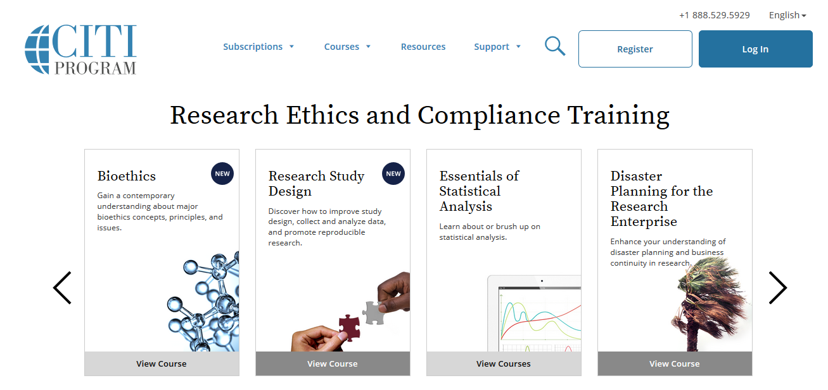

### Step 2: Click “Select Your Organization Affiliation”

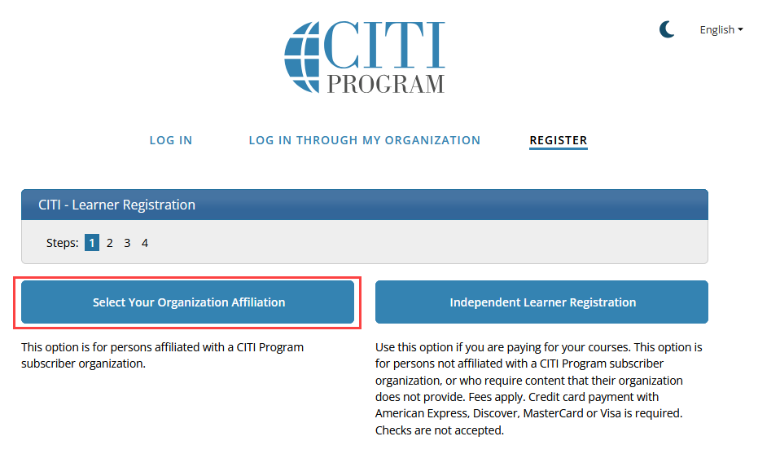

### Step 3: Enter “University of Washington”

* Do not select “University of Washington (SSO)

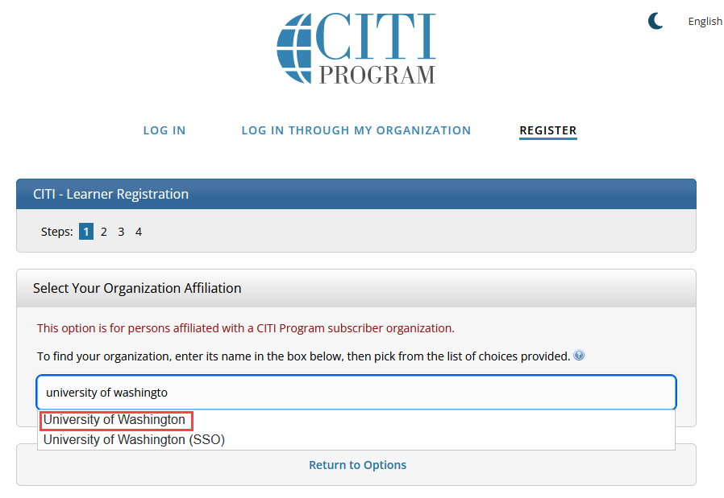

### Step 4: Agree to the terms of service, affirm that you an affiliated of University of Washington, and click “Create a CITI Program account”

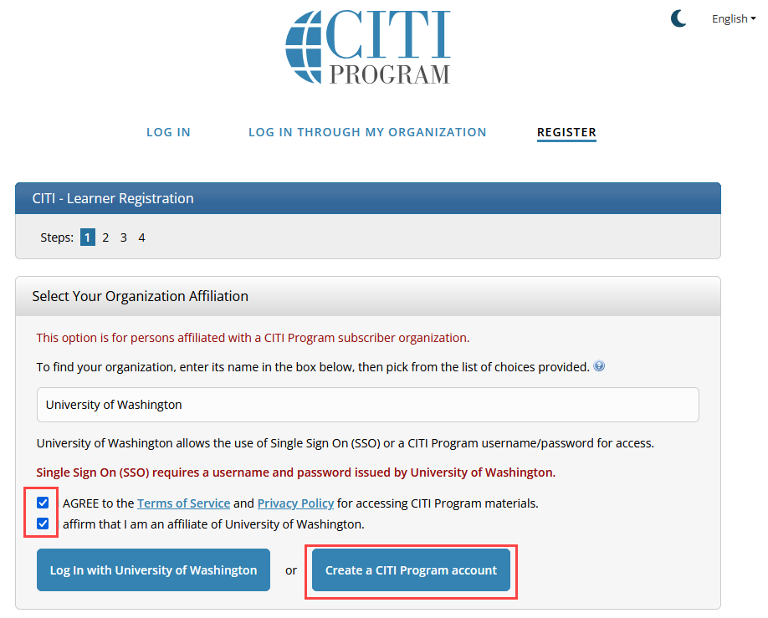

### Step 5: Complete the CITI Registration and create your Username and Password

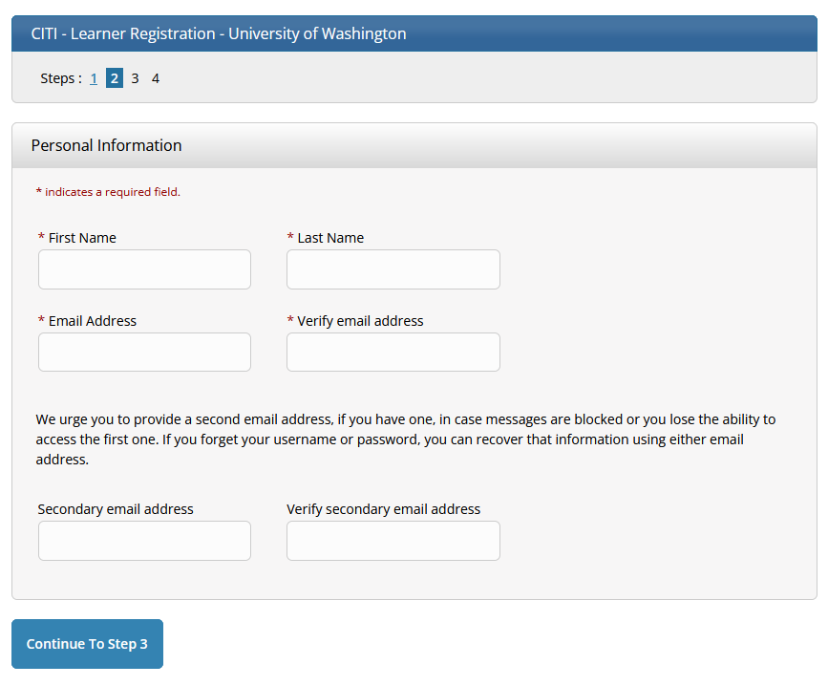

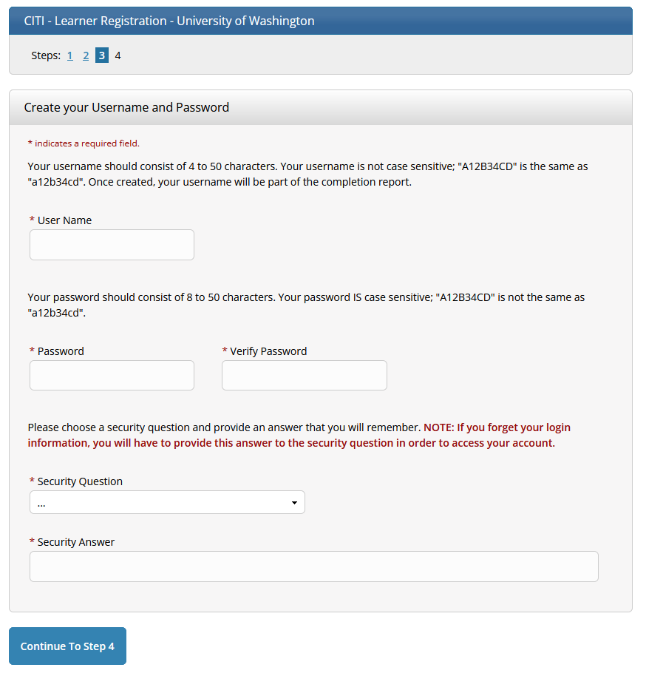

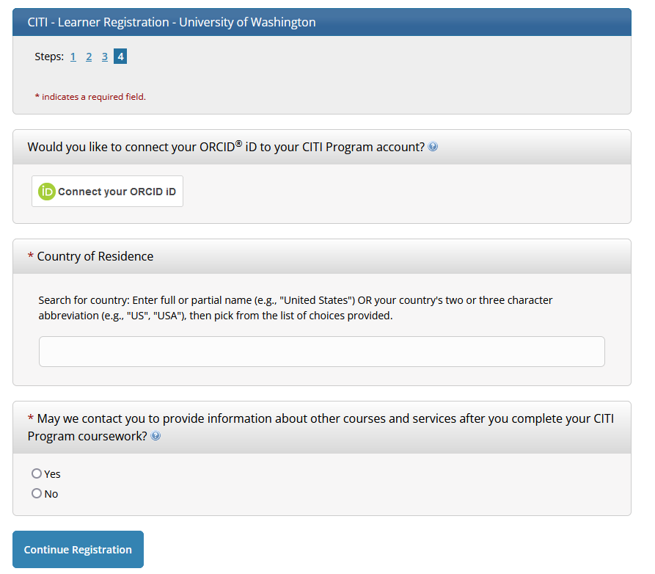

### Step 6: Indicate Your CE Credit Status

* If you are a medical professional, CE units are available for purchase after completing the GCP and Human Subjects courses. Choose whether you would be interested in CE credits.

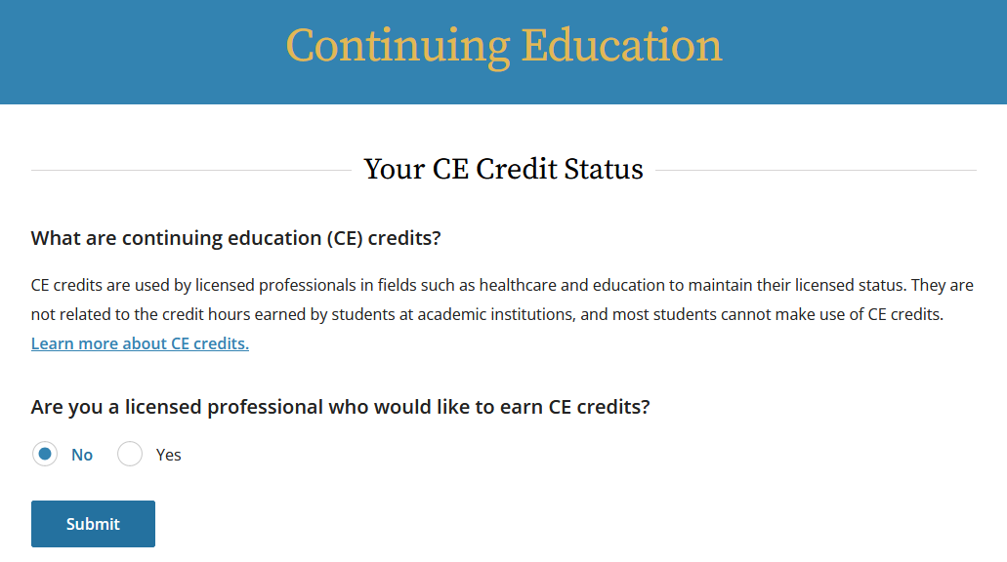

### Step 7: Affiliate with the University of Washington

* A University of Washington email account and UW NetID are not required- enter your email address and leave the UW NetID field blank

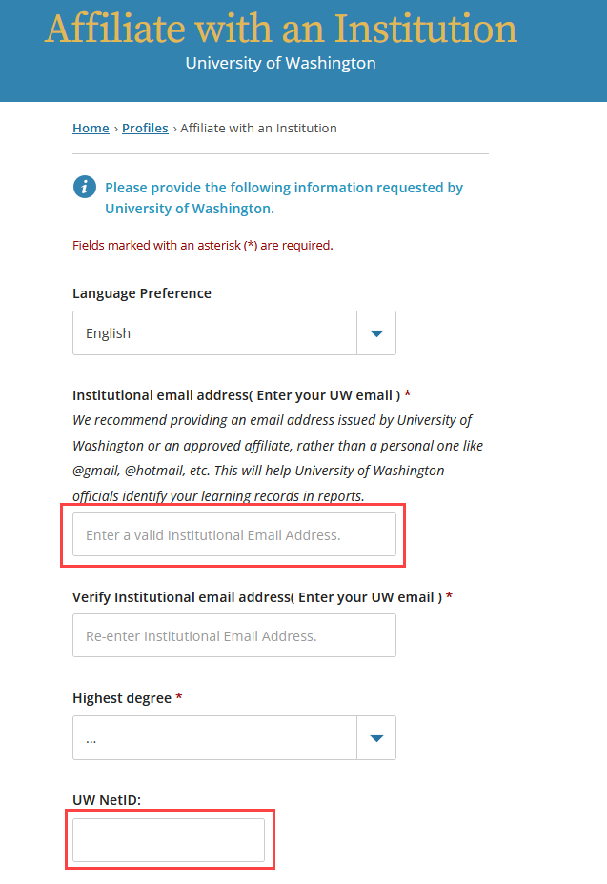

### Step 8: Indicate “UW requires me to complete a CITI course” as your purpose for registering in CITI

What is your purpose in registering for a CITI web-based training today? 

UW requires me to complete a CITI course is checked

### Step 9: Indicate the course of interest and click Next

* After this step you can complete the needed course

Choose:

* “Research with human subjects” for basic human subjects protections training
* “Research with human subjects (Refresher)” if you have previously taken the basic human subjects protections course and need to take refresher training
* “Good Clinical Practice” for GCP training tailored to drug and device trials
* “GCP – Social and Behavioral Research Best Practices for Clinical Research” for GCP training tailored to behavioral trials
* “Responsible Conduct of Research (RCR) training for any researcher supported by the National Science Foundation (NSF)”, for RCR training
* “Community-Engaged and Community-Based Participatory Research” for training in Community-Engaged and Community-Based Participatory Research

