How to decide whether a study is a NIH Clinical Trial

HSD recommends using these resources for deciding whether your research project is a NIH Clinical Trial.

- NIH Decision Tree https://grants.nih.gov/policy/clinical-trials/definition.htm

This 4-question decision tree lays out the criteria NIH uses. HSD advice about using the decision tree:
- The definition is not based on whether the human subjects are healthy or are patients.
- NIH has made it clear that it defines “intervention” very broadly.
- The very broad NIH interpretation of this criterion is the most controversial and is the most likely to be evaluated incorrectly by PIs: Is the study designed to evaluate the effect of the intervention on the participants?
- NIH considers almost all human subjects research it funds to be “health-related”.
- Clinical trials may be looking at efficacy, effectiveness, safety, or mechanisms, and may be exploratory/pilot/feasibility studies.
- It is not a requirement to have multiple groups to be considered “prospectively assigned”. NIH does consider single-arm trials to be clinical trials.
- Risk is not part of the definition.
- The number of subjects is irrelevant. NIH states that there can be clinical trials with a N=1.
- Studies need not include a comparison group to be considered a clinical trial.

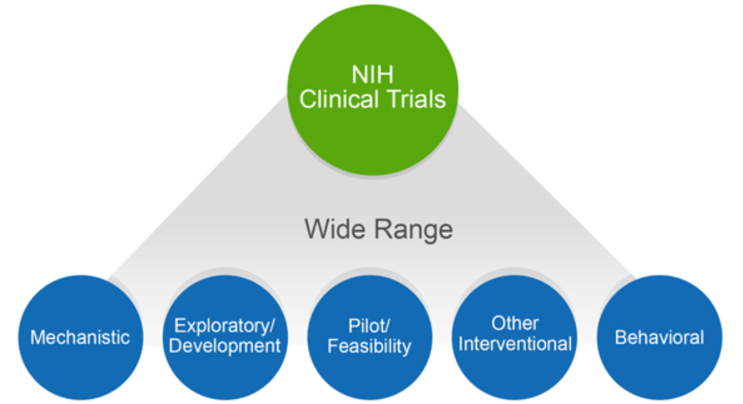

- NIH FAQs about Clinical Trials https://grants.nih.gov/grants/policy/faq_clinical_trial_definition.htm

- NIH Case Studies https://grants.nih.gov/policy/clinical-trials/case-studies.htm (scroll down the page to see them)

This is a series of short 1-paragraph descriptions of about 3 dozen hypothetical studies, written to illustrate the difference between clinical trials and studies that are not clinical trials. This is probably the single most useful resource, because PIs are likely to find at least one case study whose approach/design matches what they are considering. They are extremely revealing of NIH’s broad definition of “clinical trial”.

Example: Case Study #14. The study involves the recruitment of healthy volunteers for a respiratory challenge study; participants are randomized to receive different combinations of allergens. The study will evaluate the severity and mechanism of the immune response to different combinations of allergens introduced via inhalation. NIH considers this to be a clinical trial. The case study is analyzed in terms of the 4 criteria, to explain why.

- NIH staff. If you are still not sure after using the above resources, we suggest contacting one of the NIH staff named in the Funding Opportunity Announcement you are considering. They will expect you to have used the above resources first.

