NewProfs@UW: Making Connections to Help Launch your Academic Career

Date: September 11, 2023

Location: HUB 250

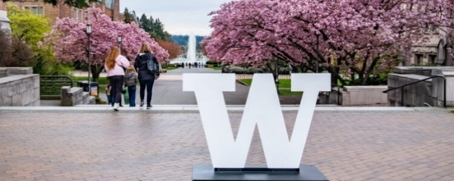

Schedule
8:30 Coffee, pastries, networking (HUB 250)
9:00 Welcome & ice breaker (HUB 250)
- Fred Nafukho, Vice Provost for Academic Personnel
- Lauren Pressley, Senior Associate Dean for Research and Learning Services, UW Libraries
- Mari Ostendorf, Vice Provost for Research
9:20 Office of Academic Personnel overview (HUB 250)
- Fred Nafukho, Vice Provost for Academic Personnel
- Marjorie Olmstead, Associate Vice Provost for Academic Personnel
- Hilaire Thompson, Associate Vice Provost for Academic Personnel
9:50 Parallel panel session
Building a Scholarship Portfolio in Arts, Humanities & Social Sciences (HUB 340)
- Chair: Chad Allen, Associate Vice Provost, Office for Faculty Advancement
- Catherine Connors, Professor, Department of Classics
- Jennifer Koski, Associate Dean, Professor of Finance, Foster School of Business
Building a Scholarship Portfolio in Engineering & Natural Sciences (HUB 238)
- Chair: Marjorie Olmstead, Associate Vice Provost, Office of Academic Personnel
- Peter Pauzauskie, Associate Professor, Department of Materials Science & Engineering
- Joel Thornton, Professor and Chair, Department of Atmospheric Sciences
- Joyce Yen, Director, UW ADVANCE Center for Institutional Change
Building a Scholarship Portfolio in Medicine & Health Sciences (HUB 214)
- Chair: Hilaire Thompson, Associate Vice Provost, Office of Academic Personnel
- David Morgenroth, Professor and Vice Chair for Research, Department of Rehabilitation Medicine
- Sunny Chieh Cheng, Assistant Professor, UW Tacoma School of Nursing & Healthcare Leadership
- Jerry Cangelosi, PhD, Professor, Department of Environmental and Occupational Health Sciences, Associate Dean for Research, School of Public Health
Building a Scholarship Portfolio in Teaching & Pedagogy (HUB 307)
- Chair: Chris Laws, Teaching Professor, Department of Astronomy
- Matt Gliboff, Associate Teaching Professor, Department of Physics
- Ann Culligan, Associate Teaching Professor, Department of Psychology
11:00 Introduction to the UW Libraries (HUB 250)
- Lauren Pressley, Senior Associate Dean for Research and Learning Services, UW Libraries
- Diana Louden, Life Sciences Librarian, UW Libraries
- Jenny Muilenburg, Research Data Services Librarian, UW Libraries
- Verletta Kern, Head, Open Scholarship Commons; Digital Scholarship Librarian; UW Libraries
11:30 Parallel panel session
Getting ready to publish: book & article publishing at UW (HUB 214)
- Chair: Elliott Stevens, English Studies and Research Commons Librarian, UW Libraries
- Stephan D. Fihn, MD MPH, Professor, Depts of Medicine and of Health Systems and Population Health; Deputy Editor, JAMA Network Open
- Nicole Mitchell, Director, UW Press
- Diana Louden, Life Sciences Librarian, UW Libraries
Support for open scholarship: working & sharing openly for maximum impact (HUB 340)
- Chair: Lauren Ray, Open Education Librarian, UW Libraries
- Liz Bedford, Scholarly Publishing Outreach Librarian, UW Libraries
- Verletta Kern, Head, Open Scholarship Commons; Digital Scholarship Librarian; UW Libraries
- Jenny Muilenburg, Research Data Services Librarian, UW Libraries
12:30 Lunch (HUB 250)
1:15 Plenary lunch panel: Collaboration within and outside UW (HUB 250)
- Chair: Mari Ostendorf, Vice Provost for Research
- David Ginger, Professor, Department of Chemistry
- Maureen Kennedy, Associate Professor, School of Interdisciplinary Arts and Sciences, UW Tacoma
- Shwetak Patel, Professor, Allen School of Computer Science & Engineering
- Tivon Rice, Assistant Professor, Digital Arts and Experimental Media
- Mark Scheuerell, Associate Professor, School of Aquatic and Fishery Sciences
2:30 Office of Research Overview (HUB 250)
- Mari Ostendorf, Vice Provost for Research
- Joe Giffels, Senior Associate Vice Provost for Research
- Jennifer Iwamoto, DVM, CPIA, Co-Director, Office of Animal Welfare
- Cecilia Giachelli, Associate Vice Provost for Research, Professor, Department of Bioengineering
3:00 Parallel panel session
Lab & field research (HUB 307)
- Chair: Ben Fitzhugh, Professor, Anthropology
- Brandon Guthrie, Associate Professor, Global Health
- Melanie Martin, Associate Professor, Anthropology
- Sharlene Santana, Professor, Biology
- Cheryl Greengrove, Associate Professor, Science and Mathematics, School of Interdisciplinary Arts and Sciences, UW Tacoma
Human subjects & clinical research (HUB 238)
- Chair: Jason Malone, Director, Human Subjects Division
- Allison R. Webel, PhD, RN, FAAN, Professor and Interim Robert G. and Jean A Reid Executive Dean, UW School of Nursing
- Joan Casey, PhD, Assistant Professor, Environmental & Occupational Health
- Wadiya Udell, PhD, Professor of Psychology, Interim Assistant Vice Chancellor of Faculty Success, UW Bothell
- Rachel E. Scherr, PhD, Assistant Professor, Physics, UW Bothell
Computational research (HUB 214)
- Co-Chair: Xiaosong Li, Associate Vice Provost for Research Cyberinfrastructure; Professor, Chemistry, College of Arts & Science
- Co-Chair: Andrew J. Connolly, Associate Vice Provost for Data Science; Professor, Department of Astronomy, College of Arts & Sciences; Director, eScience Institute
- Patrick Boyle, Assistant Professor of Bioengineering, Director of the Cardiac Systems Simulation Lab, College of Engineering and School of Medicine
- Ting Cao, Assistant Professor, Materials Science and Engineering, College of Engineering
- Ben Marwick, Professor of Archeology and Director of the Interdisciplinary Minor in Data Science, College of Arts & Sciences & eScience Institute
- Kelley Harris, Associate Professor, Genome Sciences, College of Arts & Sciences and College of Engineering
Community-engaged research (HUB 250)
- Chair: Sara Curran, Associate Vice Provost for Research; Professor, International Studies, Evans School of Public Policy, Sociology, College of Arts and Sciences
- Branden Born, Chair, Urban Design and Planning, College of Built Environments
- Elizabeth (Beth) Dawson, Assistant Professor, Division of General Pediatrics, Department of Pediatrics, School of Medicine
- Linda K. Ko, Professor and Associate Chair for Research, Health Systems and Population Health, Co-Director of the Community Engagement Program at ITHS
- Jennifer J. Otten, Associate Professor, Department of Nutritional Sciences, School of Public Health
- Carolyn West, Professor, School of Interdisciplinary Arts and Sciences, UW Tacoma
Research in the Arts, Humanities, and Humanistic Social Sciences (HUB 340)
- Chair: Kathleen Woodward, Director, Simpson Center for the Humanities, Lockwood Professor in the Humanities and Professor, English
- Jordanna Bailkin, Jere L. Bacharach Endowed Professor in International Studies, Professor, History
- Jesse Oak Taylor, Associate Professor, English
- Bonnie Whiting, Ruth Sutton Waters Endowed Associate Professor, Music
4:00 Plenary panel: Trainee mentoring (HUB 250)
- Chair: Cecilia M. Giachelli, Associate Vice Provost for Research, Professor, Bioengineering
- Bill Mahoney, Associate Dean of Student and Postdoctoral Affairs, UW Graduate School; Associate Professor of Laboratory Medicine & Pathology, UW School of Medicine; Director, Molecular Medicine & Mechanisms of Disease PhD program
- Ralina Joseph, Presidential Term Professor; Director, Center for Communication, Difference, and Equity (CCDE); Associate Dean, Equity & Justice in the Graduate School; Professor of Communication
- Sophie Pierszalowski, Director, Office of Undergraduate Research, Undergraduate Academic Affairs, Center for Experiential Learning and Diversity
- Joey Shapiro Key, Associate Professor, School of Science, Technology, Engineering & Mathmetics, Physical Sciences Division, UW Bothell
4:45 Closing Remarks (HUB 250)

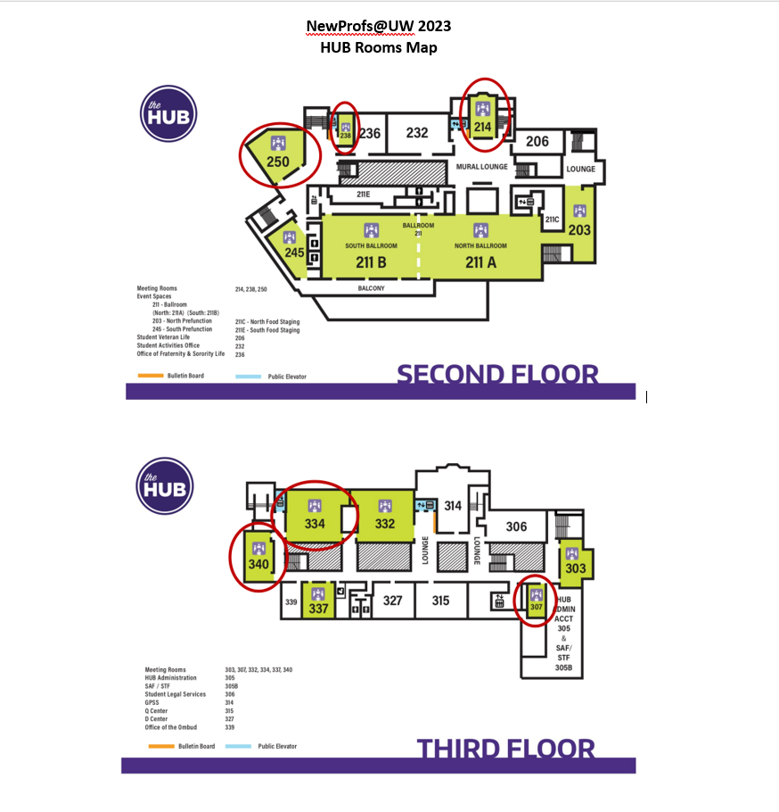

If the panel chair decides to breakout into separate book/article groups, send the smaller group to HUB 238.

