Office of Research
iSTAR Metrics: FY18 Q3
July 5, 2018

Customer Service
Office of Research Central: Royalty Research Fund (RRF)

\

Office of Research Central: Bridge Funding

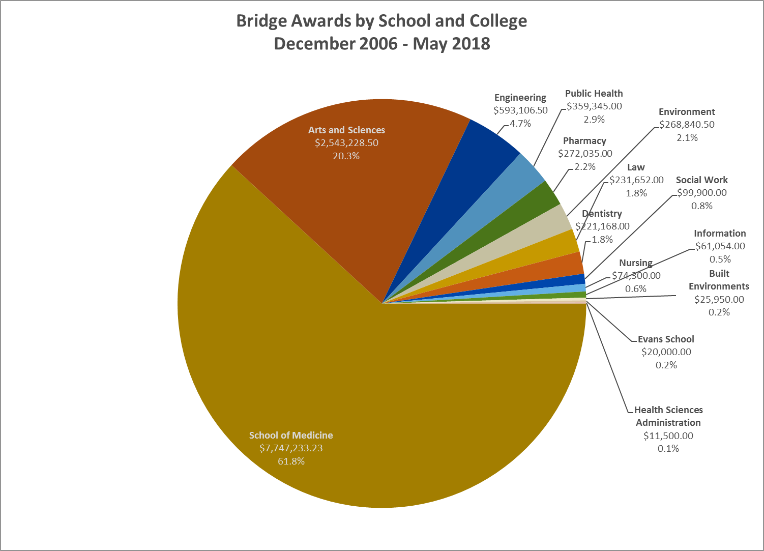
Success of Bridge Funding Program
December 2006 - May 2016
Submission Date | Distribution Provost | Distribution Matching | Total Provost and Matching | Number of  Bridge  Awards | Awardees  Receiving External Funding  within 1.5 yrs of award | % Re-ceiving Funding (total is an average) | External Grants Obtained (direct and indirect costs) | Return on Investment - fold return (total is an average)
Dec-06 | $489,177 | $549,041 | $1,038,217 | 13 | 10 | 77% | $10,408,299 | 10.0
May-07 | $394,809 | $482,486 | $877,295 | 13 | 12 | 92% | $10,779,910 | 12.3
Dec-07 | $501,802 | $584,861 | $1,086,662 | 15 | 8 | 53% | $7,575,584 | 7.0
May-08 | $523,468 | $573,117 | $1,096,586 | 12 | 6 | 50% | $9,190,014 | 8.4
Dec-08 | $576,521 | $659,742 | $1,236,263 | 15 | 9 | 60% | $14,546,157 | 11.8
May-09 | $399,662 | $459,637 | $859,299 | 10 | 6 | 60% | $2,953,107 | 3.4
Dec-09 | $394,870 | $459,637 | $854,507 | 12 | 9 | 75% | $9,841,584 | 11.5
May-10 | $290,205 | $324,394 | $614,599 | 7 | 4 | 57% | $4,563,844 | 7.4
Dec-10* | $520,670 | $548,500 | $1,069,170 | 13 | 8 | 62% | $9,057,210 | 8.5
May-11 | $441,893 | $429,066 | $870,959 | 10 | 5 | 50% | $3,558,512 | 4.1
Dec-11* | $645,752 | $649,189 | $1,294,941 | 14 | 10 | 71% | $8,197,602 | 6.3
May-12* | $645,357 | $645,797 | $1,291,154 | 16 | 9 | 56% | $8,390,917 | 6.5
Dec-12 | $653,074 | $728,755 | $1,381,828 | 19 | 13 | 68% | $7,996,561 | 5.8
May-13 | $324,830 | $376,134 | $700,964 | 8 | 6 | 75% | $5,580,753 | 8.0
Dec-13 | $730,017 | $622,388 | $1,352,405 | 16 | 13 | 81% | $12,337,212 | 9.1
May-14 | $451,776 | $555,692 | $1,007,468 | 11 | 7 | 64% | $2,673,905 | 2.7
Nov-14 | $486,773 | $586,783 | $1,073,556 | 14 | 7 | 50% | $15,968,881 | 14.9
May-15 | $516,630 | $517,700 | $1,034,330 | 12 | 10 | 83% | $6,442,091 | 6.2
Nov-15 | $318,068 | $318,769 | $636,837 | 9 | 6 | 67% | $17,569,761 | 27.6
May-16 | $195,765 | $199,128 | $394,893 | 5 | 3 | 60% | $20,635,543 | 52.3
Total | $9,501,119 | $10,270,813 | $19,771,932 | 244 | 161 | 66% | $188,267,447 | 11.2
NOTES:
1. Provost Distribution amounts displayed may be less than the original Provost distribution, as some funds were returned to the Provost budget because awardees received external funding and returned unspent funds to the Provost budget.
2. The Nov, 2015 cycle has a ROI of 27.6, a higher ROI than average. This was due to multiple factors: Nine of the awardees received bridge awards, six received external funding with high dollar grants - the largest grant was 15,915,986 (Peter Pauzauskie) and is reflected in the ROI. There are two awardees that are in extension. When they submit their final report the data will be updated and will affect this ROI.
3. * Does not include awards currently in extension

Notes:
1. The Nov, 2015 cycle has a ROI of 27.6, a higher ROI than average. This was due to multiple factors: Nine of the awardees received bridge awards, six received external funding with high dollar grants - the largest grant was 15,915,986 (Peter Pauzauskie) and is reflected in the ROI. There are two awardees that are in extension. When they submit their final report the data will be updated and will affect this ROI.
2. The May, 2016 cycle has a ROI of 52.3, a significantly higher ROI than average. This was due to multiple factors: Three of the five awardees received bridge awards including a large grant for 17,875,215 (Jay Nietz), this is reflected in the ROI. There are four remaining awardees that are in extension. When they submit their final report the data will be updated and will affect this ROI.
Human Subjects Division (HSD)

You will see that we have now combined the numbers for “initial” and “exempt” IRB applications. This is because the same application form is used for both types of situations in Zipline; we don’t know whether a specific application will be exempt until the entire review process has been completed. This was not true of our previous paper-based system.

The above sections are aggregated to show both Minimal Risk and Standard together. This includes both Zipline and DORA systems

data.

External Trainings
Unit | Session Title | Action (Training/ Outreach) | Sessions Within the Last 3 Months | Total Attendees Within the Last 3 Months
ORIS | ORIS 101: SAGE eGC1s | Training | 1 | 7
ORIS | ORIS 103: SAGE Budget | Training | 1 | 5
ORIS | ORIS 101 + 103 (POD) | Training | 1 | 10
ORIS | ORIS 102: Grant Runner | Training | 1 | 6
OSP | Intro to Research Admin (POD) | Training | 1 | 29
HSD | NIH Single IRB Policy: Training for the SOM ABC Shared Services group | Training | 1 | 16
HSD | Faculty Grants Management (participated as a panelist) | Training | 1 | 35??
HSD | Administrative Advisory Group: NIH Single IRB Policy | Outreach | 1 | 6
HSD | IRB Overview, and Clinical Trials: Presentation to Psychiatry residents | Training | 1 | 9
HSD | IRB Updates: Presentation to Radiology Faculty Meeting | Training | 1 | about 30
HSD | Dept Orthopaedics: Wide-ranging topics | Outreach | 1 | 4
HSD | Comparative History of Ideas Program: IRB Review & Approval Process for Undergraduate Students | Training | 1 | 20
HSD | Sociology: IRB Review & Approval for Graduate Students | Training | 1 | 7

Guidance, Training and Outreach - Development & Updating
Unit | Name | Action (Development / Update) | Description
OSP | Team B | Development | Meeting with NanoES leadership (4 individuals, 1 hour)
OSP | Amanda | Update | CoE Admin Mtg with ORC
OSP | Team A | Update | Undergraduate Academic Affairs
HSD |  |  | Due to a system error, this information was not captured. However, at least 2 dozen documents related to Single IRB and the use of an External IRB were created or updated in addition to three issues of themonthly HSD e-Newsletter.

