Office of Research
Guidelines for Urgent Communication
Linda Gamman

Guidelines for Urgent Communication

This document describes guidelines for the process for handling urgent, high-impact, and/or time-sensitive communication. We will use the term “Urgent” for this document. The purpose of this document is to ensure that urgent communications are identified, communicated, and escalated in a timely manner to the parties responsible for the coordination of communication efforts. Our goal is to provide timely, consistent, and comprehensive information to campus.

Definition of Urgent Communication
An urgent communication requires a response and/or action beyond the standard unit communication processes or protocols. Urgent communication has high impact, and/or is urgent, and/or time sensitive. It may require coordination across units, with campus, or external groups. When reviewing a communication piece to see if it fits the criteria of “urgent,” it is important to consider all variables or criteria from the “Urgent Communication” template, including the stakeholders affected, expected deadlines, and impact on either the Office of Research or the UW as a whole.

Assumptions
- All unit directors and communication team members will be provided with a copy of this document
- This process is intended as a guideline for most likely communication scenarios
- This document will be reviewed, at a minimum, on an annual basis and updated as necessary
- This document will be stored on the OR intranet
- Any updates must be made to all stored copies of the document

Roles and Responsibilities

OR-Central Communication Manager
The OR-Central Communication Manager (CM)is responsible for coordinating urgent communications across units or campus. Responsibilities may include:

- Intake and review of urgent communication template
- Alert communication team and/or directors as appropriate
- Indentify the appropriate medium
- Coordinate of communication piece across units and/or upper administration if necessary
- Route copies of communication piece(s) as necessary
- Communicate resolution to communication team and/or directors as appropriate
- Schedule and facilitate post-mortem meeting

Unit Communication Lead
The Unit Communication Lead is responsible for coordination of urgent communication within their unit. Responsibilities may include:
- Follow the communication process and protocols of their unit
- Review of urgent communication, following the guidelines of the “Urgent Communication” template
- Alert communication manager
- Identify the appropriate medium
- Coordinate of communication within their unit, directors, or campus
- Route copies of communication piece(s) as necessary
- Communicate resolution to communication team and/or directors as appropriate

Contact Information
The following is the contact information for the communication manager and communication leads for high-impact communication for the office of research:
Linda Gamman, OR-Central Communication Manager
Robin Hendricks, Laura Baldwin, ORIS Unit Communication Lead
Sherry Edwards, HSD Unit Communication Lead
Gretchen Davis-Richey, OSP Unit Communication Lead

Communication Process and Work Flow
The process and workflow chart on the following page illustrate the activities and responsibilities of the communication team in ensuring that urgent communication pieces are resolved in the most effective and efficient manner.

Template for High-Impact/Urgent/Time Sensitive Communication
The template for urgent communication is included in the pages that follow. This document would be used by the communication manager as a tool to gather information on incoming requests for urgent/time-sensitive or high-impact communication. The document would be used to make sure that all the pertinent information is gathered and routed and will ensure that any approvals for messaging will be handled appropriately. This is a tool for gathering information from unit partners for the development of a specific communication plan.

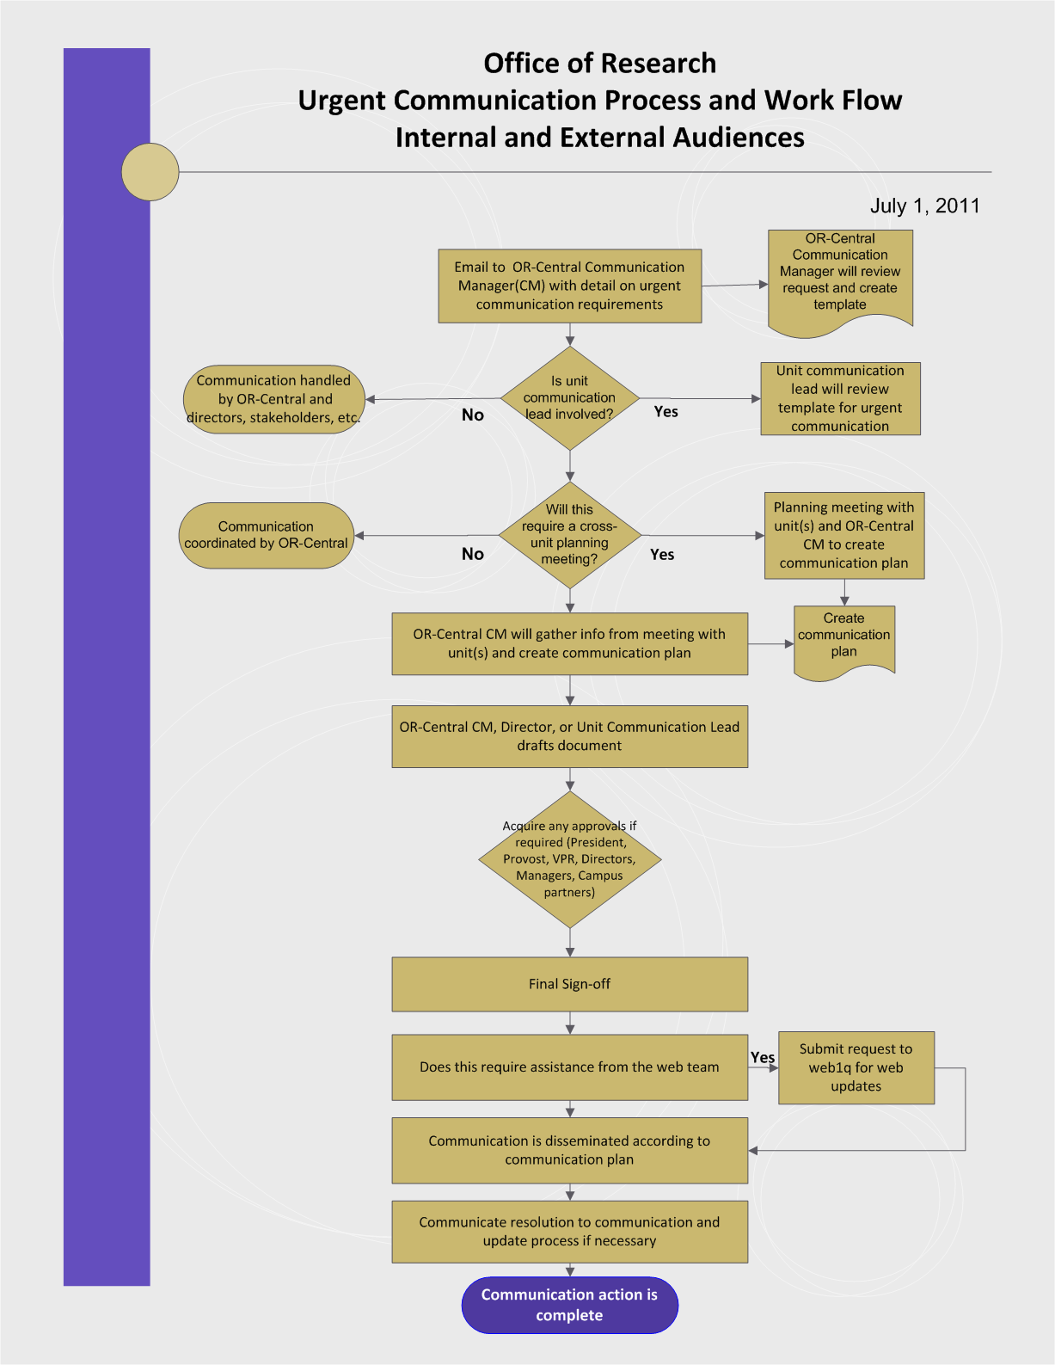
Template
High-Impact/Urgent/Time Sensitive Communication Date Received: _________

Version 3/22/11
Description of communication:

Key internal contacts:

Statement of benefits/risks/impact (if applicable):
For campus:

For OR:

For your unit:

Target date(s) and timelines

Audience/addressee list

CC list
Describe impact and who/which groups are impacted
Medium (s) | Email  Web  Meeting  Other(s): ___________________________
Level of sign-off/approval process | President  Provost  Vice Provost for Research  Director  Supervisor/manager  Other: _______________
Plan for debrief or follow-up (if applicable)
Follow-up for communication team (if applicable)
Notes:

