OR Central Medical Emergency
Clipboard Questions

Name of sick or injured person
UW workplace of person
Date and time
Recorder’s name
What parts of your body are affected?  indicate on the figure, add any notes | left right  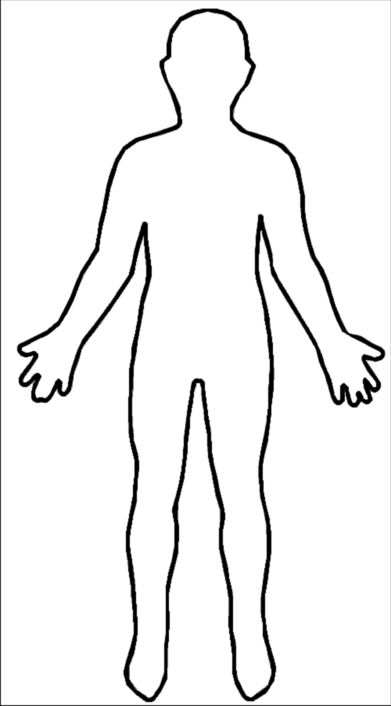
When did the symptoms begin?
How did the problem occur?
Location where problem occurred?

What have you done so far to treat this?
Is there anything else you’d like us to know?
Emergency contact name and phone #
Any other information

Check off any actions taken
____ CPR chest compressions ____ Called 911
____ CPR assisted breathing ____ ORC management informed / name: _________________
____ Defibrillation ____ Other:
____ Compression for bleeding

