Sharing Files with people outside the UW using Google Drive
This is a quick “How-to” document. There may be additional tips and approaches that are more efficient or that you may prefer.
- Open Google Chrome
- Make sure you Login using your UW Google account (vs. your personal Google account if you have one).
- Click the Google Apps waffle and then select Drive.
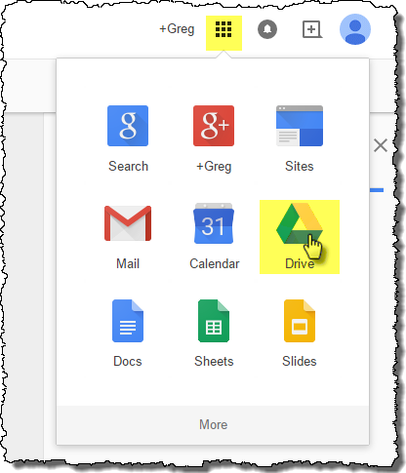
- Right-Click My Drive, select New folder….
- Give your folder a meaningful name and click Create.
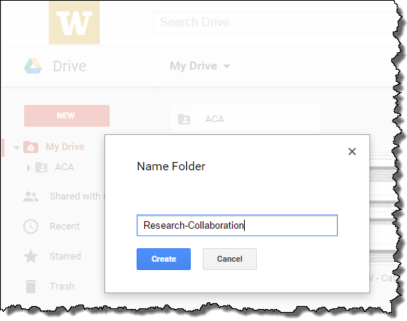
- Right-Click your new folder and select Share.
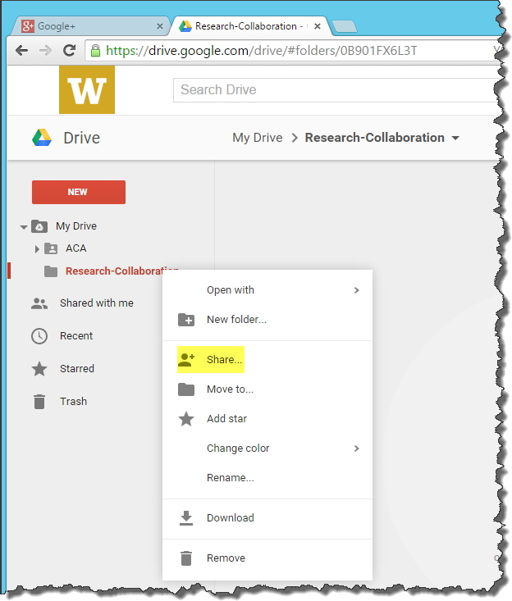
- On the Share with others dialog, select Advanced.
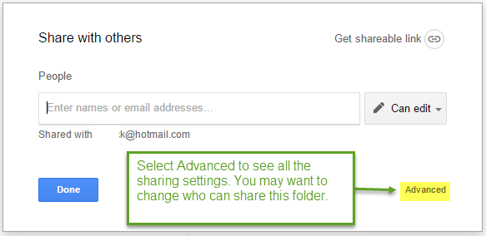
The Advanced sharing options allow you to change the default settings. For example you may want to restrict sharing so that only the owner (you) is allowed to grant permissions to access this folder.
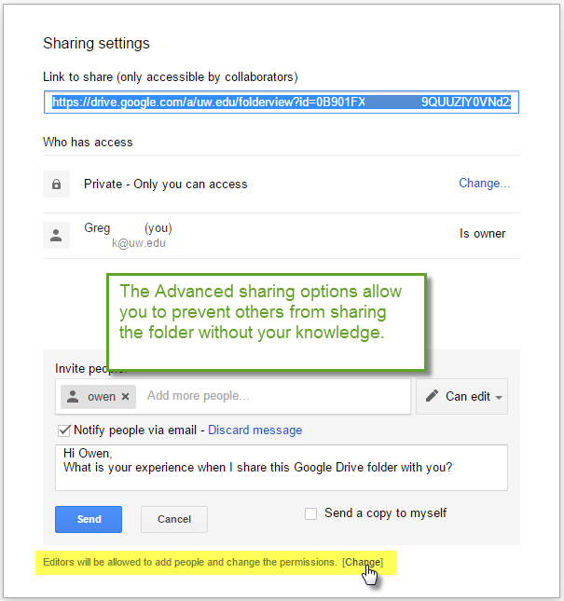
- Once you have configured the sharing options the way you want, click Send.
- You will be prompted with an Are you sure? dialog box. If you are sure, click Yes.
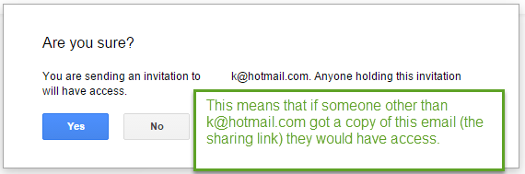
The external recipient will receive an email that with a link to access the shared folder. 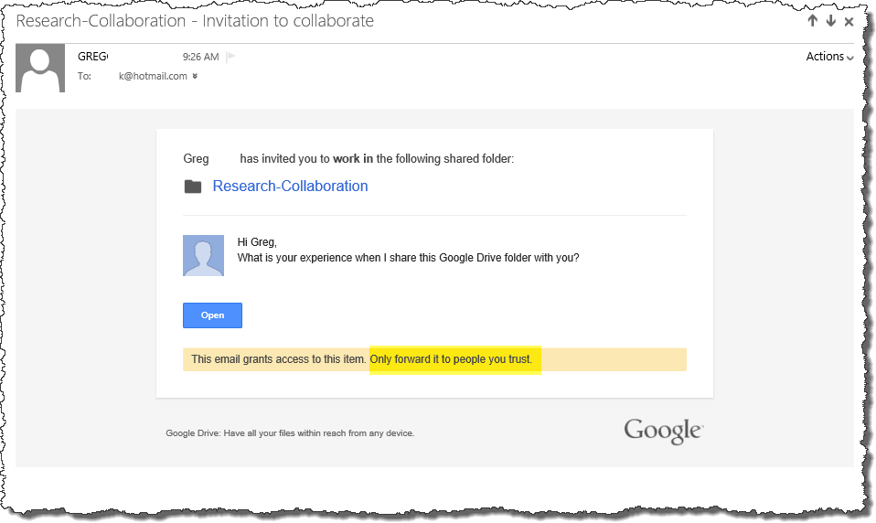
If the email address used to share with the external recipient is not a Google account they will have to create a Google account and login with that account to gain access to the folder.
