- Purpose
Provide instructions for UW researchers for creating a user account for the PRS web-based data entry system for the ClinicalTrials.gov (CT.gov) website. This is a one-time requirement that will allow the researcher to register clinical trials, edit the trial record, and report trial results.

- Definitions

Organization account The UW organization account at CT.gov is called UWashington.
PRS The web-based data entry system for ClinicalTrials.gov.

- Timeline

5 minutes  Prepare & send email for new account | Up to 2 work days  Wait to receive login information | 5 minutes  - Log into PRS system  - Change temporary password

- Procedures
4.1 Send an email message requesting an account to: hsdreprt@uw.edu .
- Put CT.gov in the subject line.
- Include your full name, telephone number, and UW email address.
4.2 Within 2 business days, you will receive an email with your login name and a temporary password.
4.3 Log into the PRS system using UWashington as the organization, your login name, and temporary password.
4.4 Navigate to the Accounts tab and select Change Password to replace your temporary password with something you can remember.

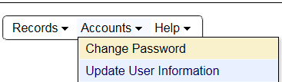

- Related Information
HSD Clinical Trials Registration webpage
HSD How to Register a Clinical Trial webpage
HSD How to Report Clinical Trial Results webpage

