SDB 101 for Student Accounts User Guide

Guide Contents:

An overview of the topics in this guide

The tasks a department can accomplish on SDB (Student Data Base)

Student Fiscal Services Commitment to Departments

How to get online SDB access

How to get SDB training

SDB 101 for Student Accounts

Screen Name | What it is
Moving Around | Getting Started on SDB
M6-4 | View Payment & Charge on Account
M6-12 | Add Tuition & Fee Charges
M6-14 | Student Information Summary
M5-5 | View and Add Memos on Account
SRT 630 | View and Add Holds on Account

Overview of Topics

Departments can access the Student Data Base (SDB) system to view student information and, in some cases, have limited update access while using the Student Account SDB screens. If you want to have access to view student accounts in SDB you can request access when your User ID is set up or after your User ID has been established. This guide shows the steps for viewing a student’s account on the SDB system and lists transactions departments can do directly on the system.

Department Tasks that Can Be Accomplished on SDB

View details of a student’s payments, charges, and aid that has posted to their account.

Check a student’s enrollment status, address, student account balance, etc.

View holds on a student’s account. Some departments have the ability to place holds.

View memos on a student’s account.

Student Fiscal Services’ Commitment to Departments

We will provide a user guide and training modules, along with in-person training to help you navigate the SDB system.

Online access to SDB – How to Get Set-up

Step 1 – Download, print and complete the appropriate Request Access to the Student Database (SDB) form for your campus (Seattle, Bothell and Tacoma all have separate forms).

Step 2 – Get required signatures and route as indicated on the bottom of the form.

Step 3 – After receiving your SDB User ID and Entrust Token, send an email to SFS Computing that includes:

Subject line that reads “SDB User Access”

Your first and last name

Your SDB User ID code

Reasons you need SDB access

For example - To view student accounts for advising purposes

SDB Training – How to Enroll
Go to this link to enroll in an introductory class:
https://catalysttools.washington.edu/webq/survey/sfscust/59762

SDB Student Accounts 101
Getting Around on SDB

There are short-cuts that can save you time while navigating the system. These are outlined on this keyboard.
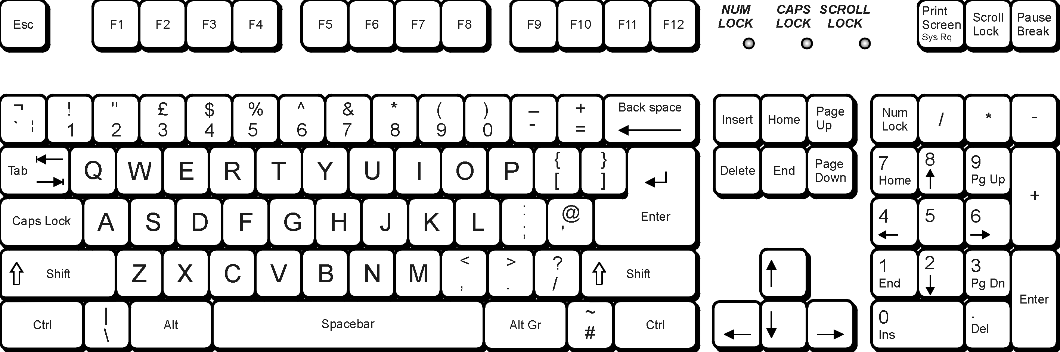
Top of the screen
Soft Enter to move
down to the next
row/field
The outside enter to
accept changes

Page Up/Page Down to go
forward and backward through
screens you have viewed
Holding Shift while using
the Tab key allows you to
go back to previous fields
(opposite of Soft Enter).
“
30
”
and
“
31
”
entered into the
action fields will scroll the
screen forward and backward
to show further data.
Tab moves the cursor
to the next field
that allows changes

How to Logon to SDB
Getting Started

- When you open up SDB, the first screen you will see is the Sign-on Screen.

Logging In
To use the student accounts portion of the SDB you must first log in.
- Enter your assigned User code – this is the code you were given by the Registrar’s Office when you received your SDB access.
- Enter your chosen Password – note that you’ll be prompted to change your password every 60 days.
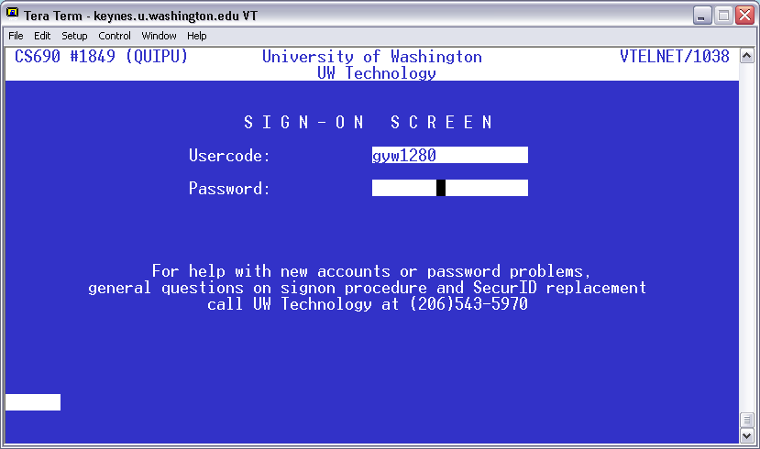

- On the PRN Screen, enter the numbers displayed on your Entrust Token.

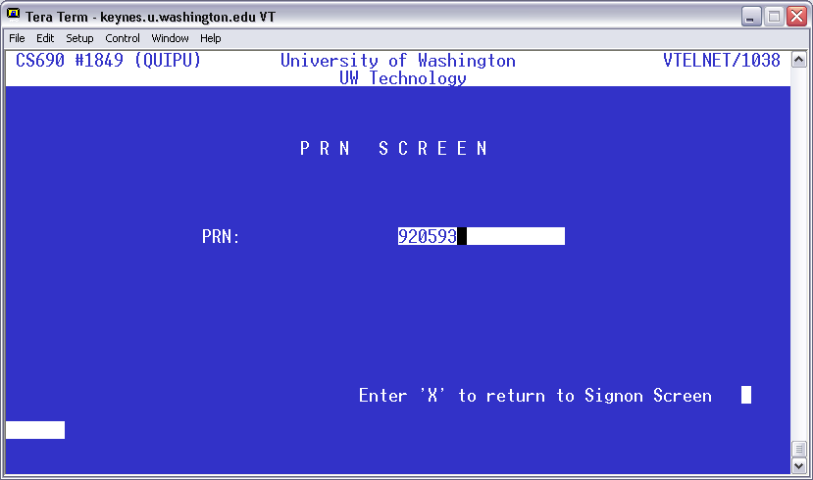

- On the Main Menu, enter your choice as “SDB”

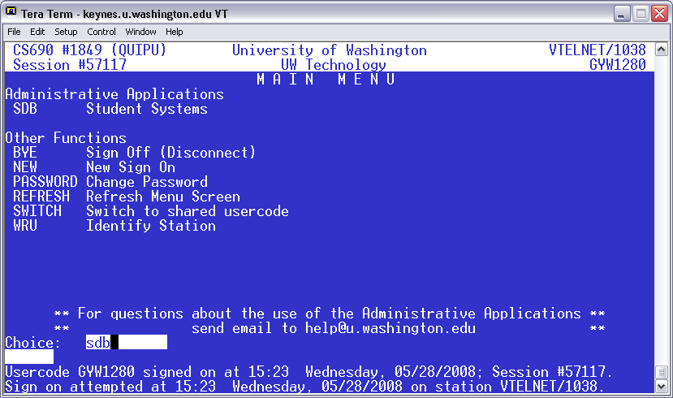

- This screen contains a warning reminder about the Family Educational Rights and Privacy Act, or FERPA. FERPA requires that we use the information about the student only in the performance of our duties at the University of Washington, and that we limit access to this information to persons authorized by the student.

In the Home position (upper left corner of the screen), type MENU6
- Although there are other menus, most of the screens you’ll need for fiscal information are on Menu 6.

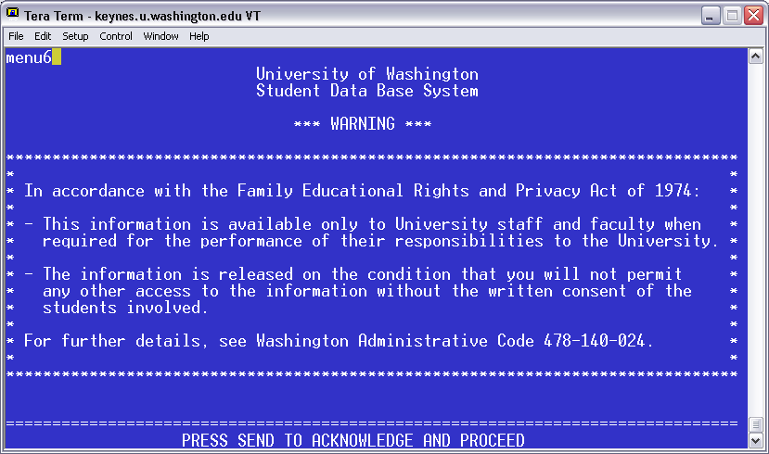

- The MENU 6 screen lists the individual action codes and their functions. From here you can access an individual student’s account:
- Enter the student number in the field marked “STD”
- Tab over to the “ACT” field and enter the Menu Screen number

SDB Menu Screen shots | Menu 5, Menu 7 & Menu 5
SDB has different types of screens. One group shows registration information while other groups show student account or even financial aid information. For our purposes, we are looking at the student accounts screens. Registration screens are marked “SRT” in the top left corner of the screen while student account screens are marked “SAT. SAT screens are organized into four menus with up to 25 different options per menu. You navigate student account screens by typing the menu screen numbers in the lower right corner of the screen. You may not have access to all screens listed on the menus. In Menu 6 you can choose up to 22 different action codes.

Below are pictures of Menu 8, 7, and 5 to help you navigate if you need to use screens in those menus’.

Menu 8

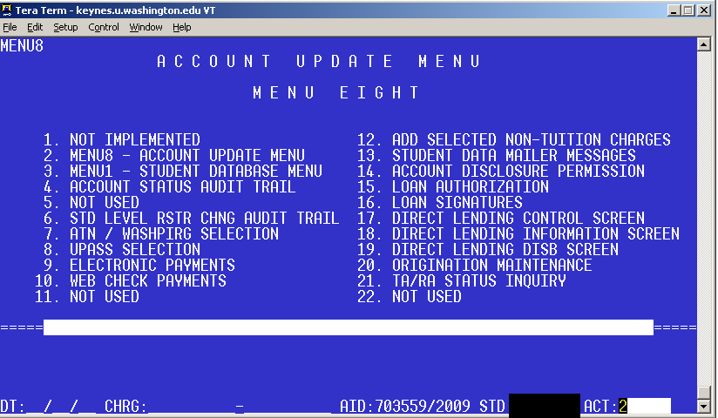

Menu 7

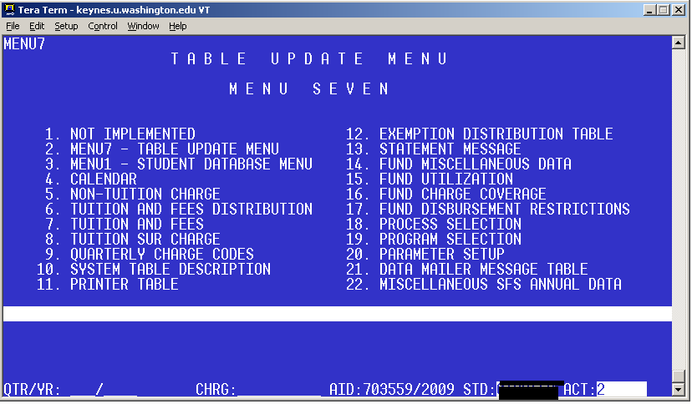

Menu 5

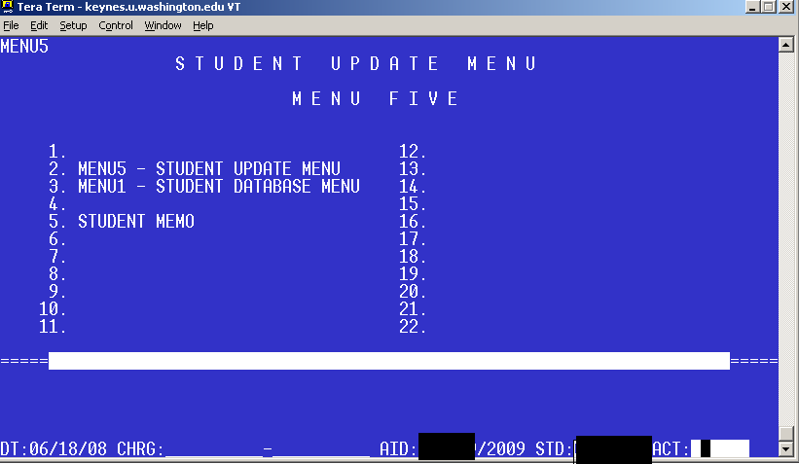

You may have access to one or more of these menus. When you first go into the SDB system, you can access any of these menus by typing the menu number in the upper left corner. Menu 6 is the location of where the majority of the screens you will use are found.

Menu 6 displays all action options in the Student Account Section of SDB system. You can see the action options by selecting “Y” at the Menu prompt in the lower middle of the screen.

M6-4 - How to View Payments & Charge Detail on Account
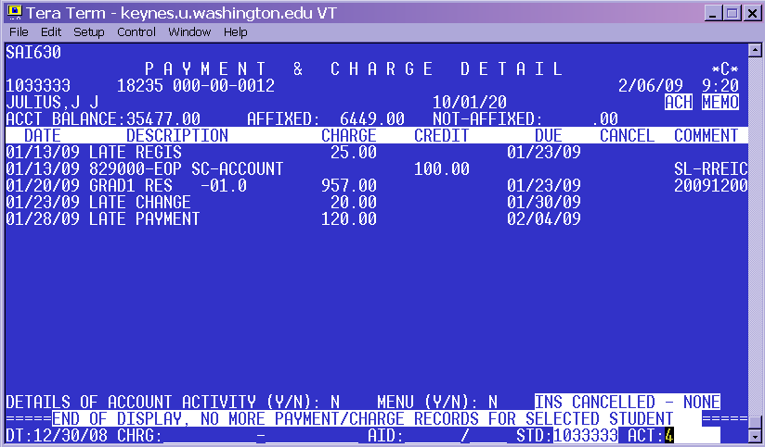
Charges
Tuition
Fees
Upass
Payments
Check
Web Check
Loans
Fin. Aid
Scholarships
Credit Card
To view a student’s account activity:

- Type the student number in the STD field
- Type M6 4 in the ACT field
- Hit the outside enter

This will bring up the student’s account information for the most current quarter.
Going from the top right to the left there are a number of different items you can see about this student (see the red/white boxes above).

- Student number
- Social Security Number (not all offices are able to view this information)
- Birth date
- Aid & Payments (credits to the student’s account)
- Charges (debits to the student’s account)

Additionally, on the right hand side of the screen under the date, you may see messages.
See below for their meaning:

Message | What it means
ACH | Student is signed up for direct deposit
MEMO | There are comments about this student on screen M5-5
COLL | Student has funds in Collections
INFO REL | Student has authorized one or more persons to view their student account information

There are seven columns in the middle of the page which give you account activity information. See below for their meaning:

Column Name | What it tells you
Date | The date of the transaction
Description | Brief description of the transaction
Charge | The amount a student was charged
Credit | The amount of money given to the student
Due | The date a payment is due on a charge
Cancel | The date a transaction was cancelled*
Comment | The User/system ID or other comments related to a transactions

Viewing Previous Quarter Activity

Normally SDB will default to the first day of the current quarter. To see previous quarters you need to change the date.

- Go to the field marked DT
- Enter the earliest date you want to see
- Hit the outside enter

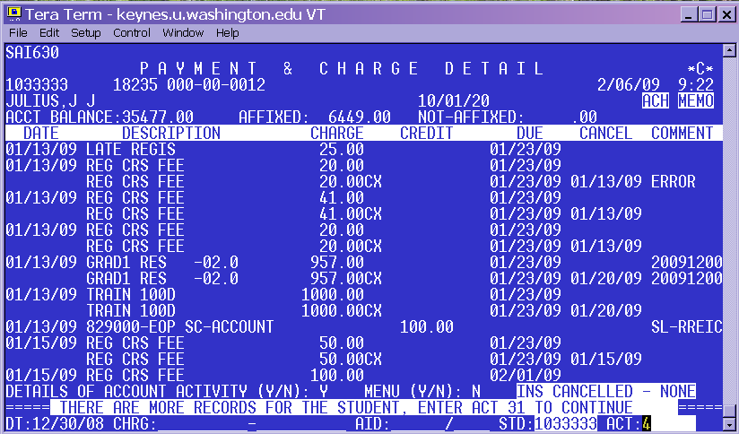
To put the detail on, tab to the Y/N and enter Y

Viewing Cancelled Transactions

M6-4 defaults to hide the cancelled transactions. Cancelled transactions can include payments, charges and disbursements of aid to a student. To view cancelled transactions:
- Go to the “Details of Account Activity” field
- Change the N to a Y
- Hit the outside enter- the screen will refresh and show all cancelled transactions

Scrolling from page to page on SDB

To move from one page to another in SDB, in most screens:
- Go to ACT field
- Enter 31 to move forward and
- Enter 30 to move back.

A Few of the screens will allow you to move forward by pressing enter.

M6-12 – Viewing and Adding Tuition & Fee Charges

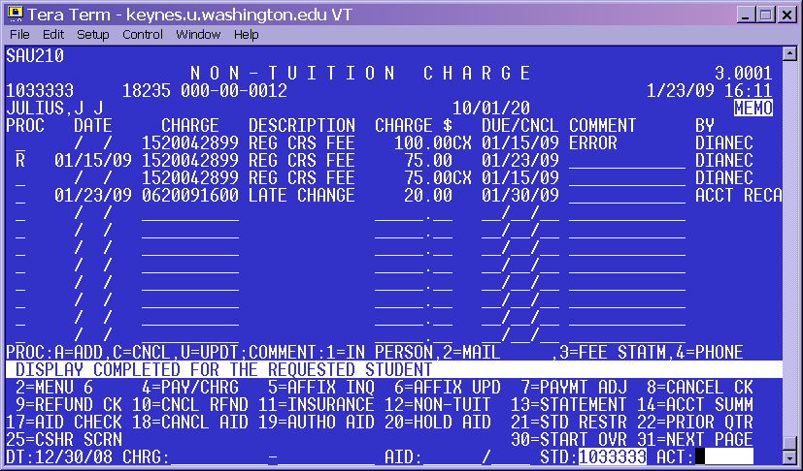
Enter Code:
A=Add
U=Update/Change
C=Cancel

To view additional tuition or fee charge detail and/or to post tuition and fee charges go to M6-12:
- Go to the ACT field
- Type M6-12
- To change students, type the student number in the STD field
- Hit the outside enter

There are eight columns on the middle of the screen. See below for their meaning:
Column Name | What it is
PROC | Where you put the code for the action:  A=Add, U= Update/Change, C=Cancel. See red/white box above
Date | Date of the transaction
Charge | Charge Code*
Description | Name for the charge code used
Charge | Amount of charge that was posted or cancelled
Due/CNCL | Date a charge was due or cancelled
Comment | The reason for the charge
By | The user who posted or cancelled the charge **
*Charge codes are made up of four parts XX-XXXX-X-XXX: (as: xx-yyyy-q-xxx)
X = number specifying type of charge, Y=year, Q=quarter, X=number identifies what specific charge the code represents.
An example of a charge would be 9020084411
90 | 2008 | 4 | 411
All 90’s are loan charges | This refers to the calendar year: from January 2008 through December 2008 | This is the quarter code: 1=Winter, 2=Spring, 3=Summer, 4= Autumn | This is the specific code indicating the type of loan. For example, 411 means a short-term loan

**A user code does not mean that an individual person has posted the charge. The SDB system also posts some charges automatically and has its own user codes like SA80115 or Acct Reca.

To add a charge:
- Type A in the PROC Field
- Type the charge code in the charge field
- Type the amount in the second charge field
- Type in the date it is due
- Add any necessary comments
- Hit the outside enter- the charge should post
To cancel a charge:
- Type C in the PROC column
- Enter a comment in the comment field, if applicable
- Hit the outside enter- a second posting will show on this screen that the original post has been cancelled

*Note: If the system will not let you cancel the charge, you will need to contact
Student Fiscal Services to assist you.

To update a charge
- Type U in the PROC column
- Type over the amount and/or due date
- Add any relevant comments
- Hit the outside enter

*Note: If the system will not let you update the charge, you will need to contact
Student Fiscal Services to assist you.

M6-14 – Student Summary Screen

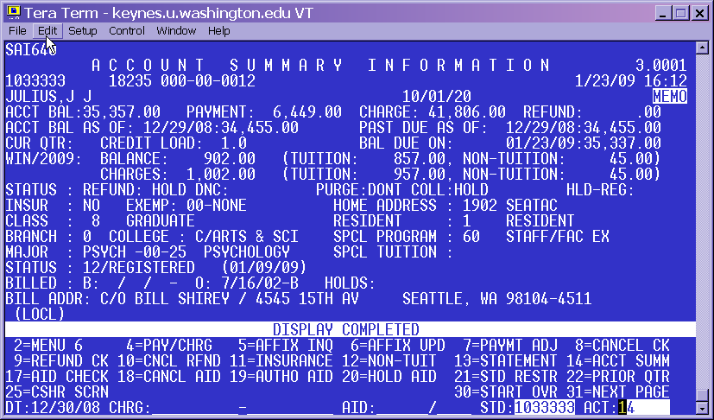
Balance as of the End of the Business Day.
Major
Class
Residency Code
Number of Credits
Current Balance
To view a student’s class status and other registration information go to M6-14.
- Type the student number in the STD field
- Type M6-14 in the ACT field
- Hit the outside enter

Beginning at the top left corner you may see the following information:
- Student number
- Social security number (not all offices have access to this information)
- Birth date
- Name
- Account balance (the default is the current date)
- Credit load
- Class
- Branch
- College
- Major
- Status
- Residency Status

Possible applications for this information:

Troubleshooting budget issues
This screen can be very helpful when you are trying to find out why a budget isn’t disbursing. Oftentimes a budget may have restrictions that do not match up with the information on this screen.

Troubleshooting tuition charges
The class & resident information on this screen determines the tuition rate a student is charged. If the information on this screen does not accurately reflect the student’s current class code and their current resident status, it is possible that the student may be charged an incorrect tuition rate or be deemed ineligible for a particular scholarship.

Viewing a student’s balance for a specified date
You can also use this screen to determine what a student owed on a specific date in the past.

To do this:

- Type the date you want to know the balance in the “Acct Bal as of” field
- Hit the outside enter. The amount shown will change to match the date specified.

M5-5 - Viewing and Placing Memos

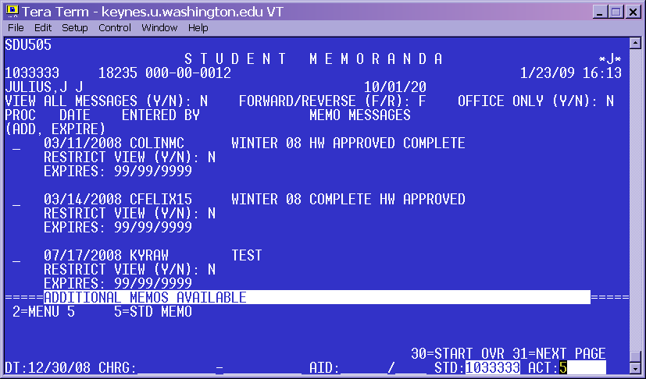

The Memo Screen M5-5 is used to view messages entered by central offices. To view comments on a student:
- Type the student number in the STD field
- Type M5 space 5 in the ACT field
- Hit the outside enter and it will bring up the memo screen
- When there are more memos, you can type “31” to go to the next page. Continue to type 31 to see all memo pages. Type “30” to return to previous pages.

If not specified, comments “expire” in three months. This means you may not see them when you initially come to this page. If you want to look at all comments listed on this student:
- Type a Y in the “View all messages” field.
- Type N to see only messages that have not yet expired

SRT630 – Viewing and Placing Holds

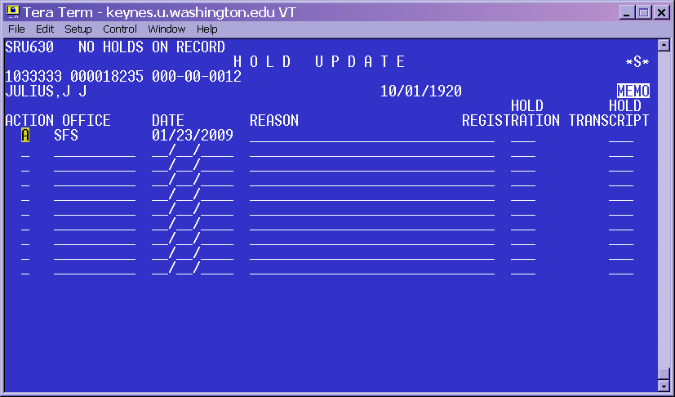
Office Placing Hold

The SRT630 screen shows holds on a student’s registration and/or transcripts.
The office that placed the hold needs to remove it. Refer students to the appropriate office to resolve the hold issue.

If your office is authorized to place holds on SRT 630, follow these instructions to add a hold:
- Type an “A” in the Action column
- Type your office abbreviation under the “office” column. In some cases, your office abbreviation may auto-fill.
- The current date will auto-fill in the date column.
- If appropriate, put a comment under reason.
- Type a “Y” or “N” under the Hold transcript and /or Hold registration columns and hit the outside enter. A “Y” in the “hold registration” column indicates that the student cannot make any changes to their schedule, including adding or dropping classes. If there is a “Y” in the “hold transcript” column the student cannot get an official transcript from the registrar. Your office policy determines which option you choose.

If your office has placed a hold on a student’s record, you can also remove it. To cancel a hold:
- Type a “D” in the action column in front of the hold
- Hit the outside enter.

