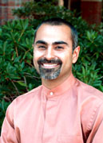

ARTICLE ON SANJEEV KHAGRAM
BROWN BAG PRESENTATION
OCTOBER 11, 2005

By Dick Simmons

Financial Management employees thoroughly enjoyed the presentation of Sanjeev Khagram at the Brown
Bag session sponsored by the FM Diversity Team on October 11. Sanjeev is the faculty director for the Marc Lindenberg Center for Humanitarian Action, International Development, and Global Citizenship and an Associate Professor in the Evans School of Public Affairs.

Sanjeev presented a very inspirational life story of being born of Indian parents in East Africa who came
to the United States as a refugee at the age of 5. His very interesting personal story was a good mixture of
relevant information on history, diversity, and achievement. We were very pleased that Sanjeev adjusted
his travel plans to be with us.

